Project Deliverable 2

Name: Mathew Correia

Student number: LMHHJCQT3

Faculty Name: Information Technology

Module Code: ITECA3-B12

Module Name: Web Development and e-Commerce

Table of Contents

[Introduction 3](#_Toc137037169)

[Link to site: 3](#_Toc137037170)

[Prototyping 4](#_Toc137037171)

[Prototype 1: 4](#_Toc137037172)

[Prototype 2 5](#_Toc137037173)

[Phone view 6](#_Toc137037174)

[Designing 7](#_Toc137037175)

[Class Responsibility Collaborator (CRC) cards 8](#_Toc137037176)

[Enhanced Entity Relationship Diagram (EERD) 8](#_Toc137037177)

[Context Diagram 9](#_Toc137037178)

[Data Flow Diagram (DFD) 9](#_Toc137037179)

[Use Case Diagram 10](#_Toc137037180)

[Database Design 10](#_Toc137037181)

[Coding 11](#_Toc137037182)

[Homepage: 11](#_Toc137037183)

[Shop page: 12](#_Toc137037184)

[Workout page 13](#_Toc137037185)

[Register/login page 14](#_Toc137037186)

[Database/Login process 15](#_Toc137037187)

[Sample PHP Code 17](#_Toc137037188)

[Sample HTML Code Main page 19](#_Toc137037189)

[Shop html 21](#_Toc137037190)

[Workout html 22](#_Toc137037191)

[Register/login page 23](#_Toc137037192)

[Sample JavaScript Code 25](#_Toc137037193)

[Add to cart 25](#_Toc137037194)

[Register/Login 27](#_Toc137037195)

[Main page 27](#_Toc137037196)

[Sample CSS Code 28](#_Toc137037197)

[Main page 28](#_Toc137037198)

[Shop page 38](#_Toc137037199)

[Workout 43](#_Toc137037200)

[Register/login page 48](#_Toc137037201)

[Sample MySQL Table Screenshots 51](#_Toc137037202)

[Conclusion 51](#_Toc137037203)

# Introduction

My project is an e-commerce website that aims to provide users with a seamless and user-friendly shopping experience. With a wide range of products and intuitive features, our platform allows users to browse and purchase items conveniently from the comfort of their own homes.

The website offers a diverse collection of products, ranging from gym equipment to electronics, clothes, and more. Each product is carefully curated to ensure quality and relevance to our users' interests and needs. Whether they are looking for the latest gadgets, gym equipment or good quality clothes, my platform has something for everyone.

One of the key features of my website is the personalized user experience. Upon registration and login, users have access to their own accounts, where they can view their order history, manage their preferences, and save their favourite products. This allows for a tailored shopping experience and makes it easier for users to track their purchases and make informed decisions.

To elevate the shopping experience on my e-commerce website, I have carefully designed and developed a user-friendly interface that prioritizes ease of navigation and efficient product discovery. My intuitive interface allows users to seamlessly explore a wide range of categories, apply relevant filters, and utilize a robust search feature to quickly find their desired products. By presenting detailed information, captivating images, comprehensive descriptions, and transparent pricing, we empower users to make informed purchasing decisions confidently.

In summary, my e-commerce platform offers a wide range of products, personalized user experience, intuitive navigation, and secure transactions. I strive to provide a seamless and enjoyable shopping experience for my users, making it easier than ever to discover and purchase their desired items online.

# Link to site:

<http://gymtime.great-site.net/>

# Prototyping

## Prototype 1:

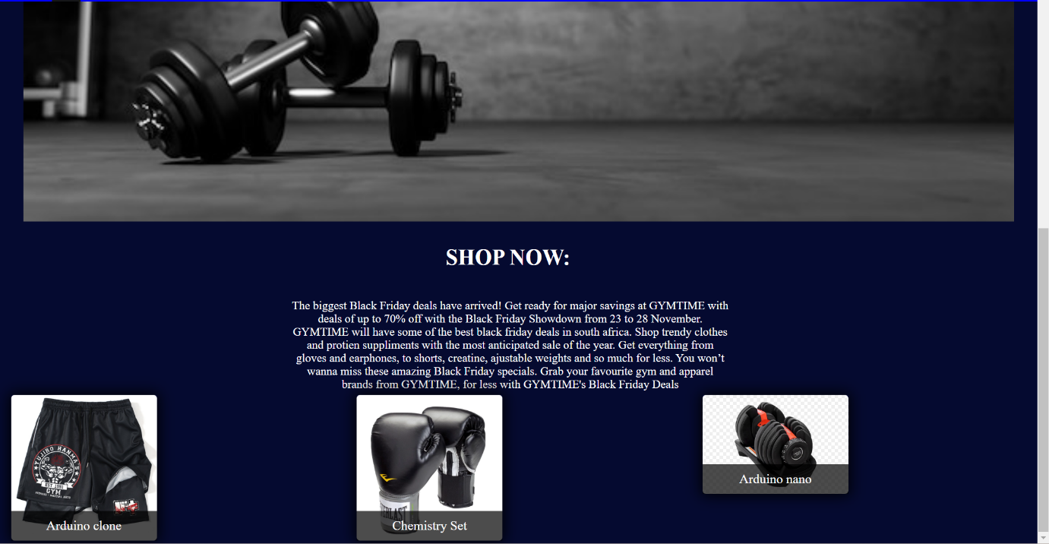

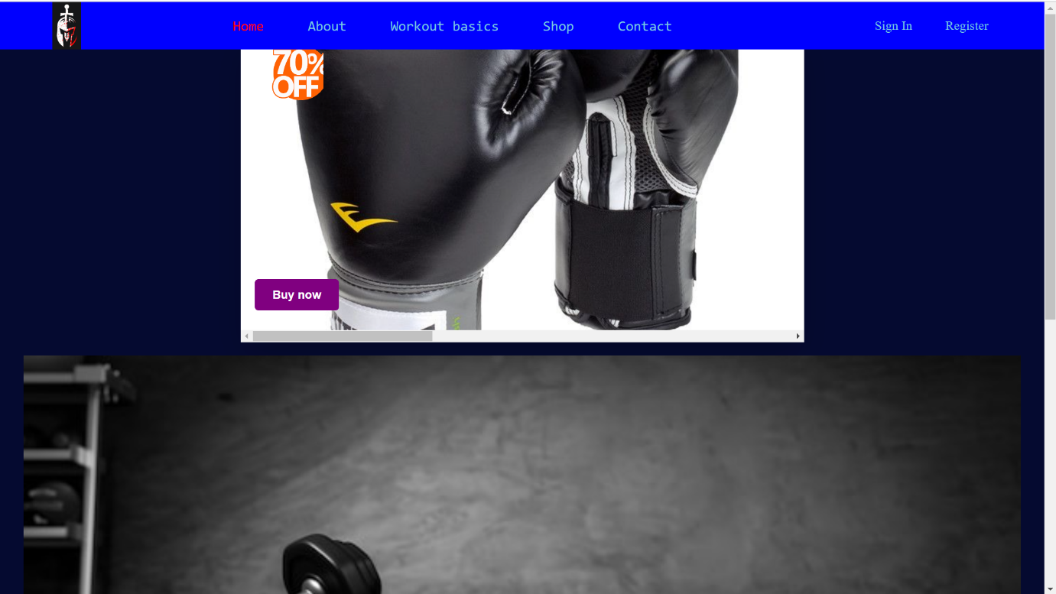

## A picture containing text, screenshot, graphic design, design Description automatically generatedA collage of black dumbbells and headphones Description automatically generated with medium confidenceWorkout_King - Google ChromePrototype 2

### Phone view

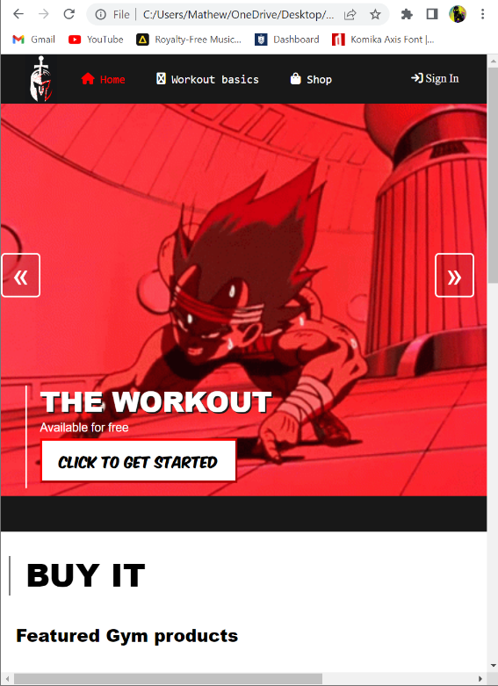

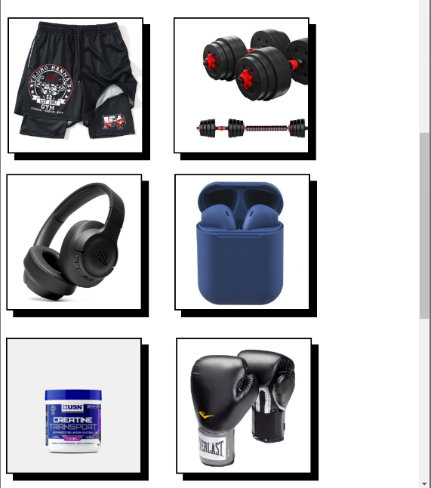

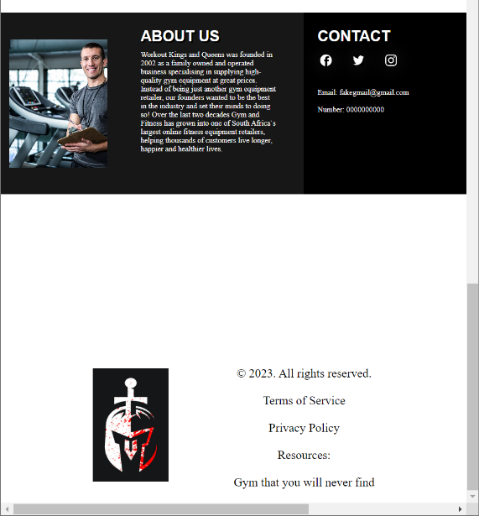

# Designing

## Class Responsibility Collaborator (CRC) cards

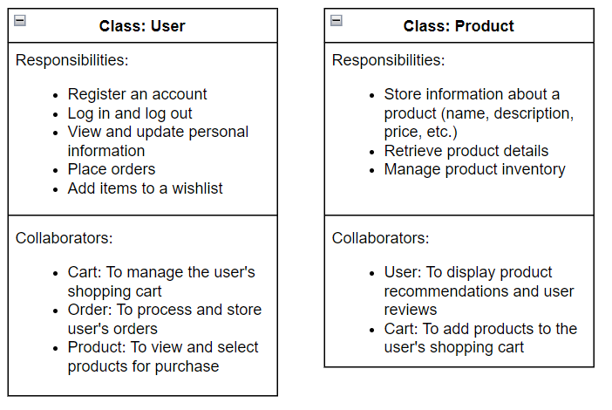

## Enhanced Entity Relationship Diagram (EERD)

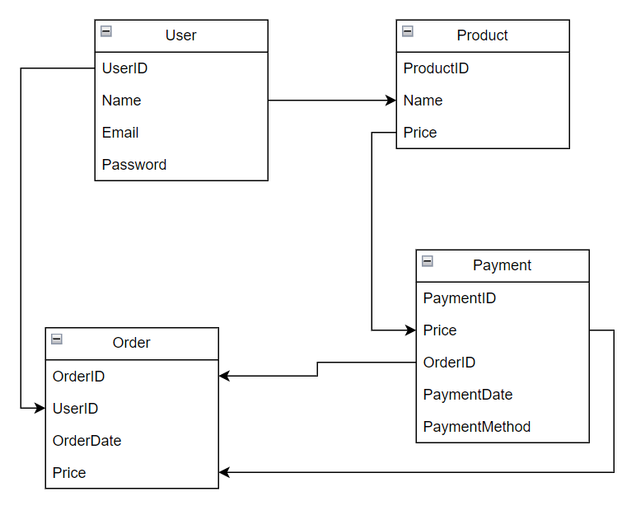

## Context Diagram

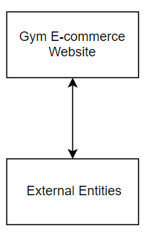

In the above diagram, the "Gym E-commerce Website" represents my system. The external entities are the entities or systems that interact with my website, such as:

Users: These are individuals who visit my website, browse products, make purchases, etc.

Payment Gateway: This represents the external payment service provider that handles secure transactions.

Shipping Service: This entity represents the external shipping or logistics company responsible for delivering the products to customers.

The arrows in the diagram indicate the flow of information or interactions between my website and the external entities. For example, users interact with my website to browse products and make purchases, while the website communicates with the Payment Gateway for processing payments, and with the Shipping Service to coordinate product delivery.

## Data Flow Diagram (DFD)

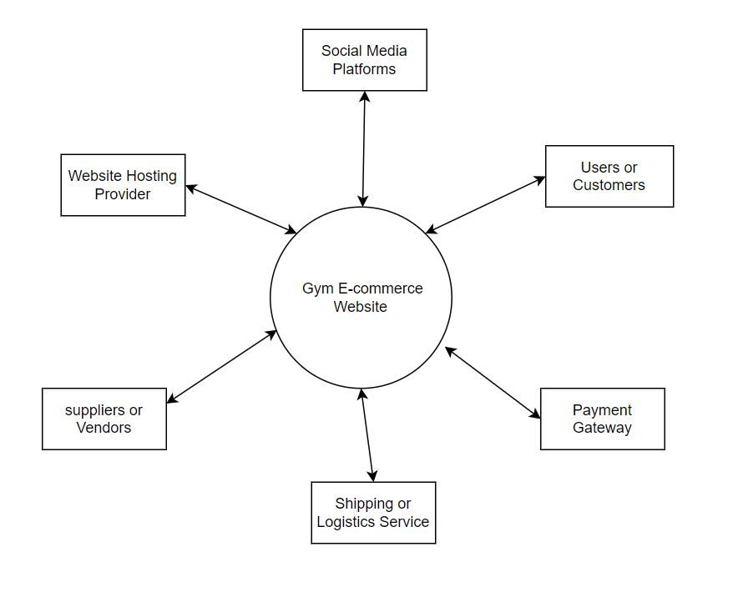

## Use Case Diagram

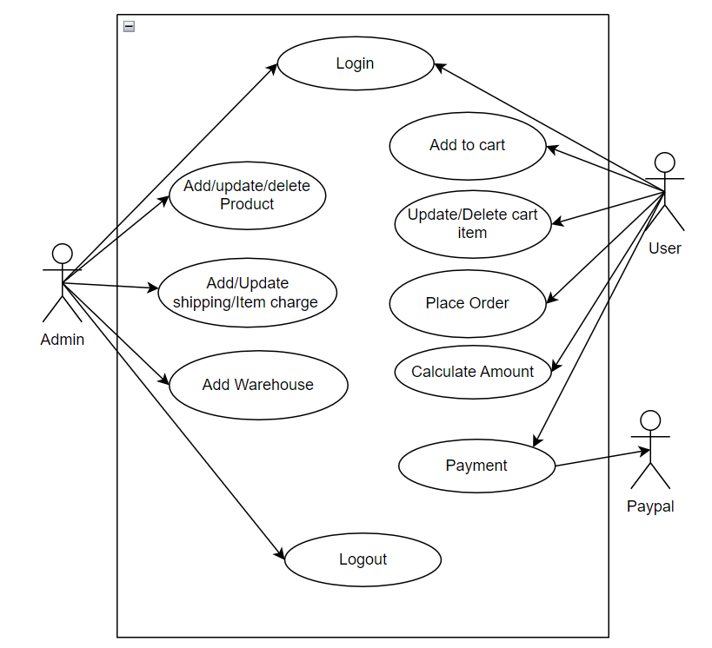

## Database Design

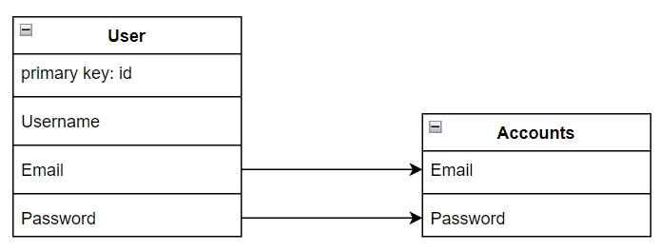

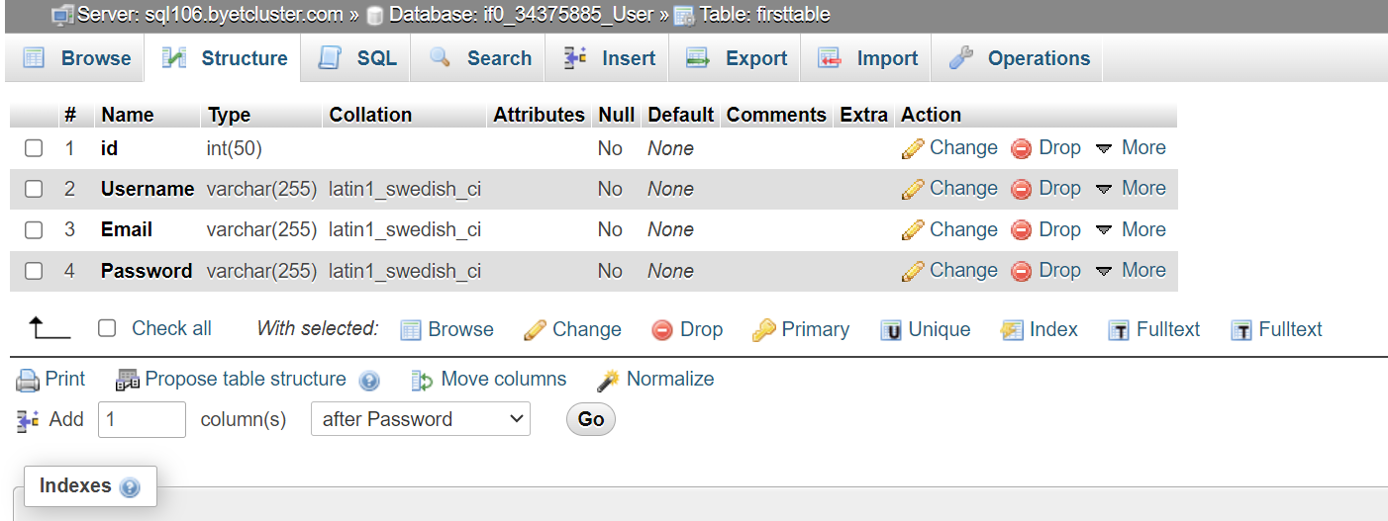

# Coding

## Homepage:

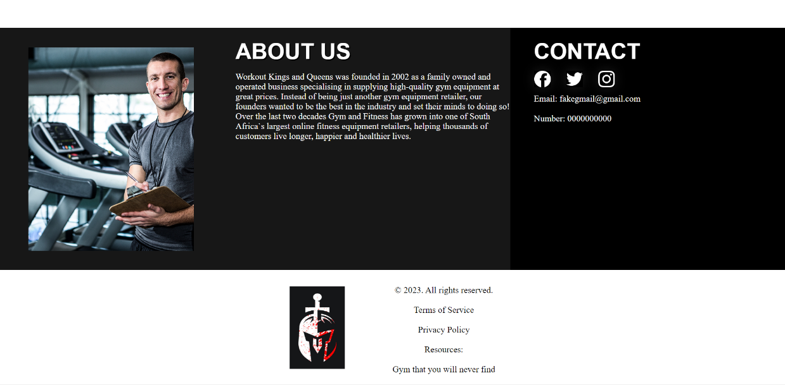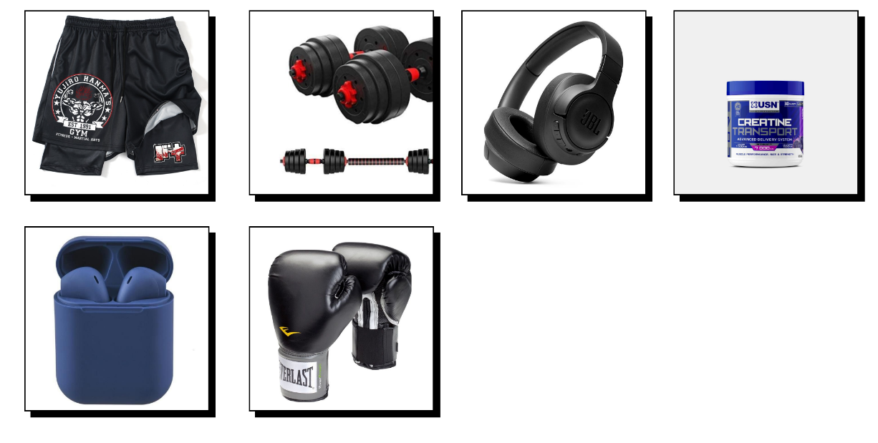

### Shop page:

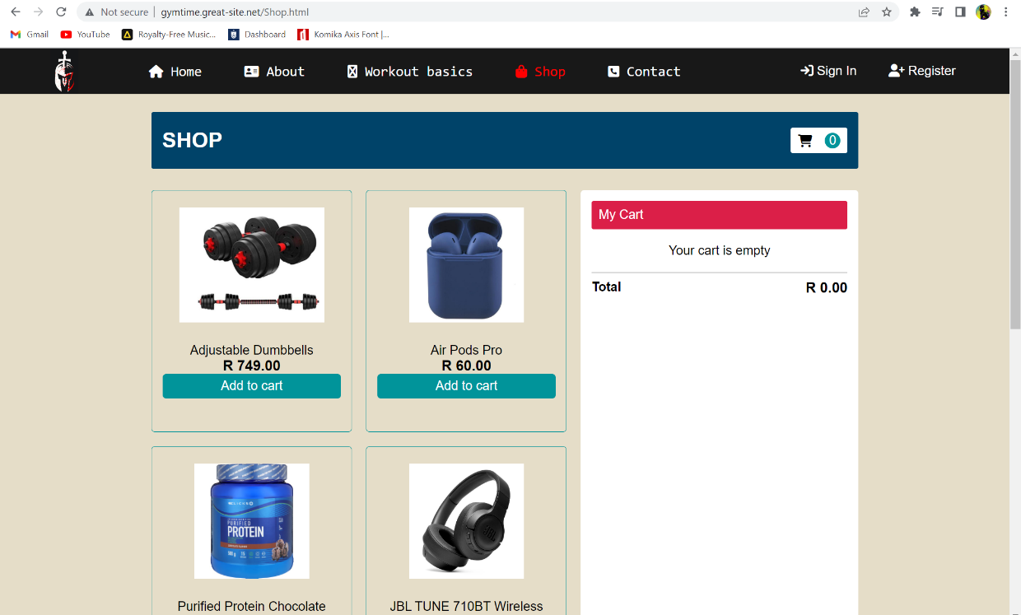

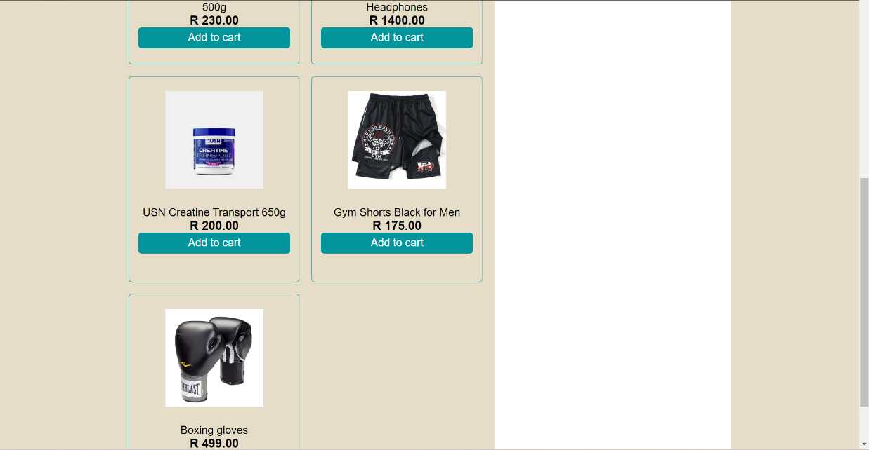



### Workout page

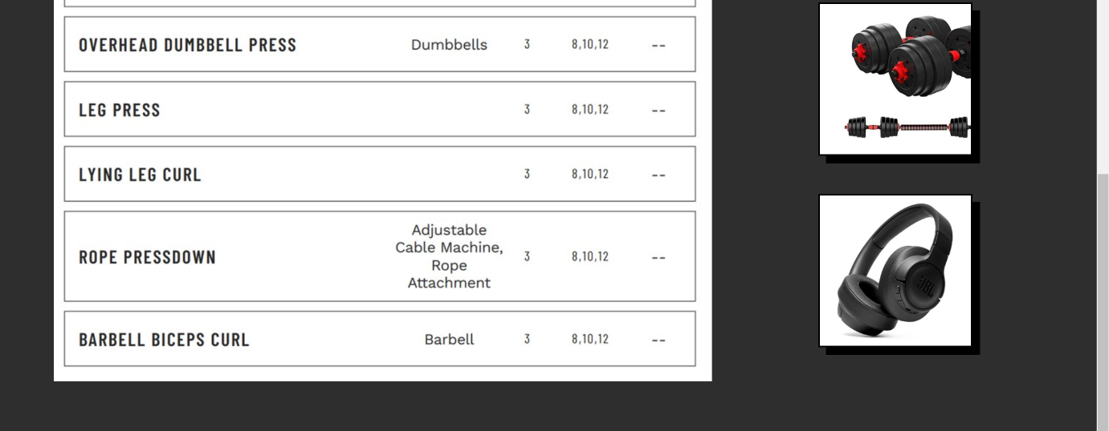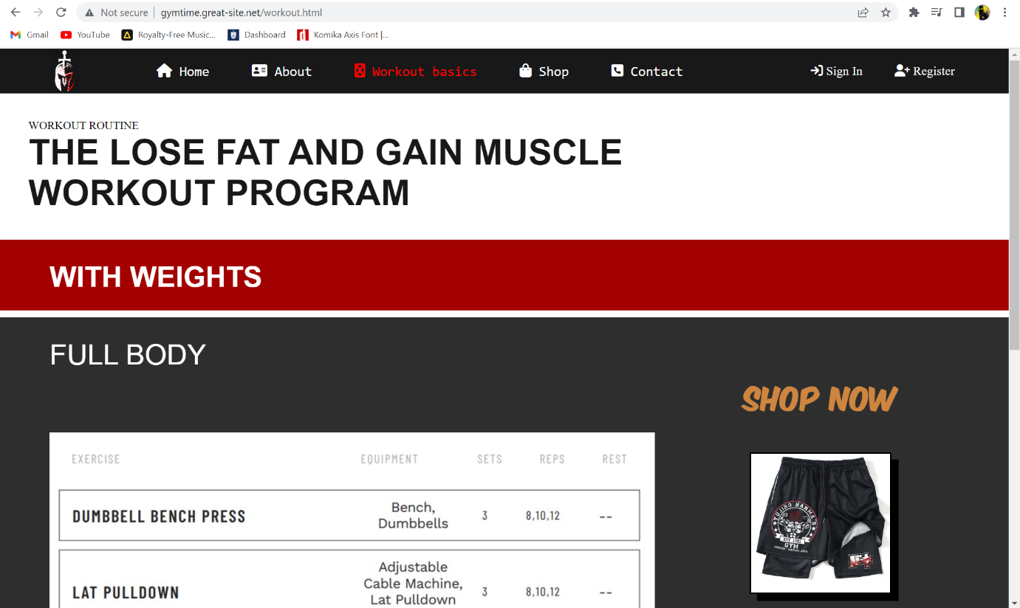

### Register/login page

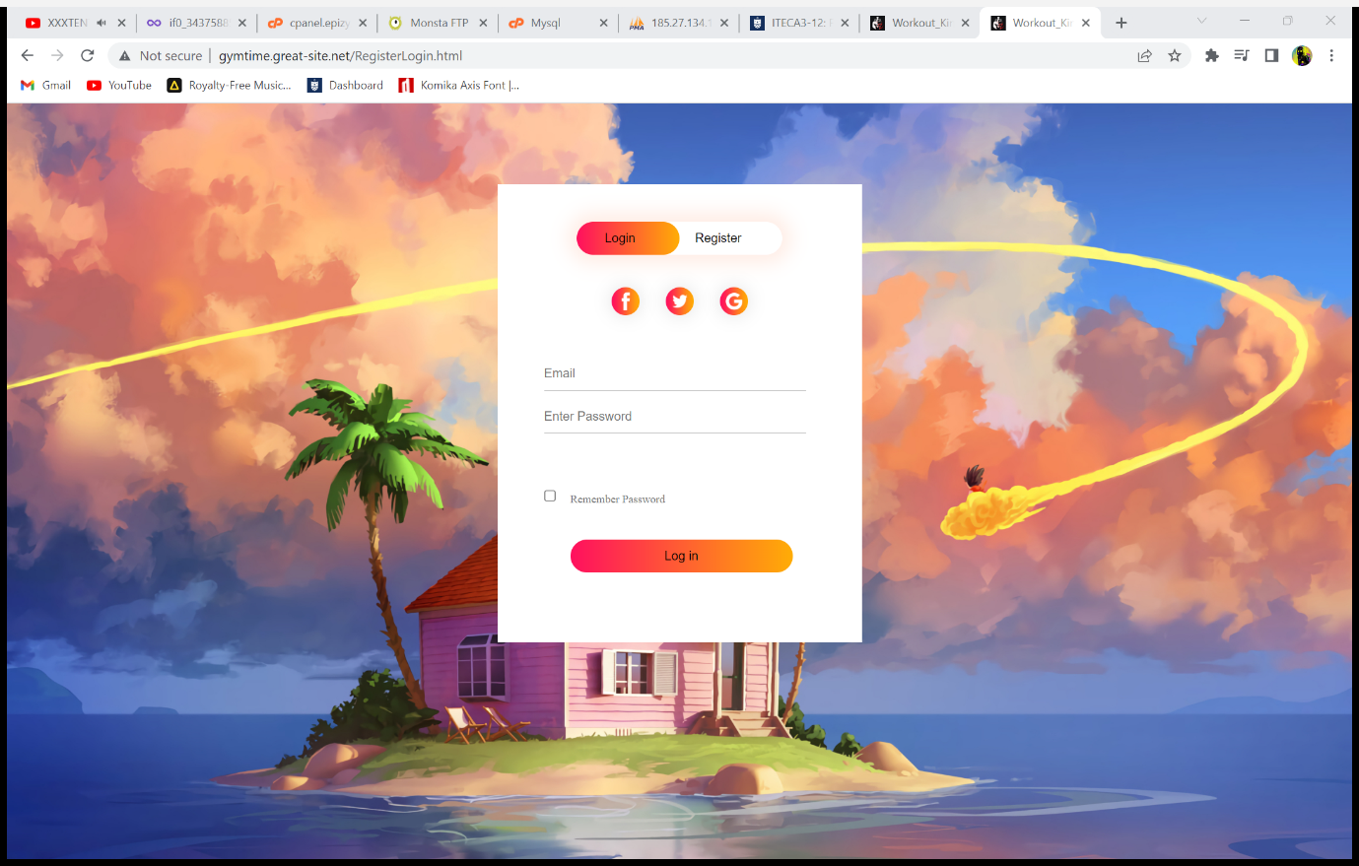

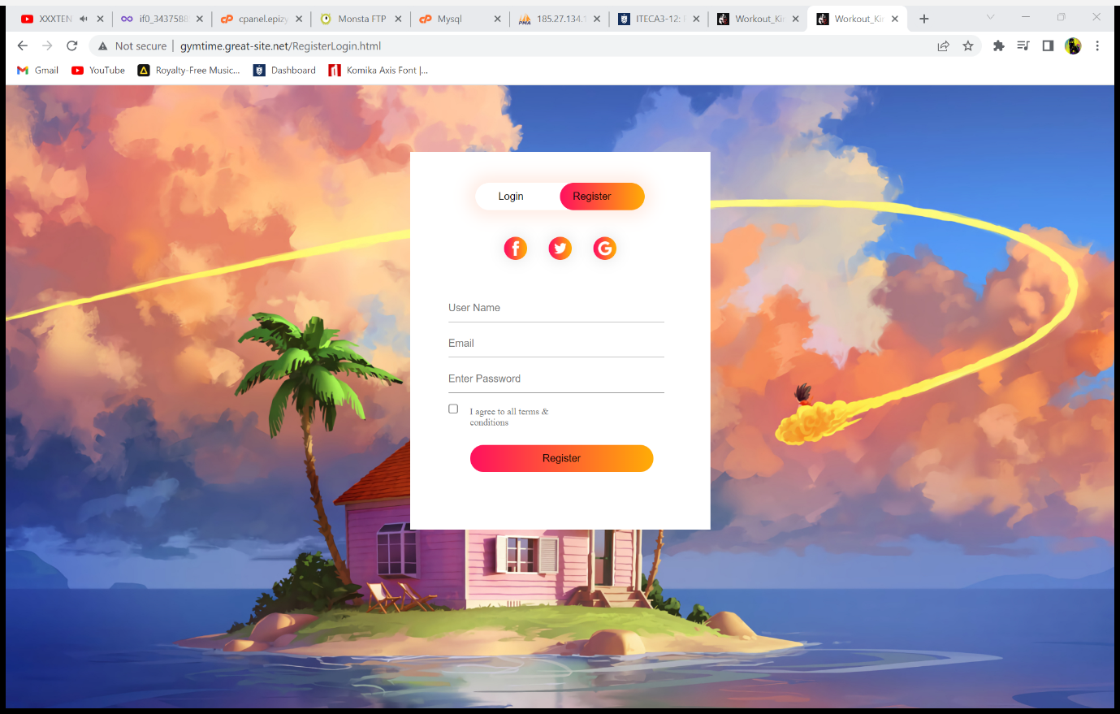

### Database/Login process

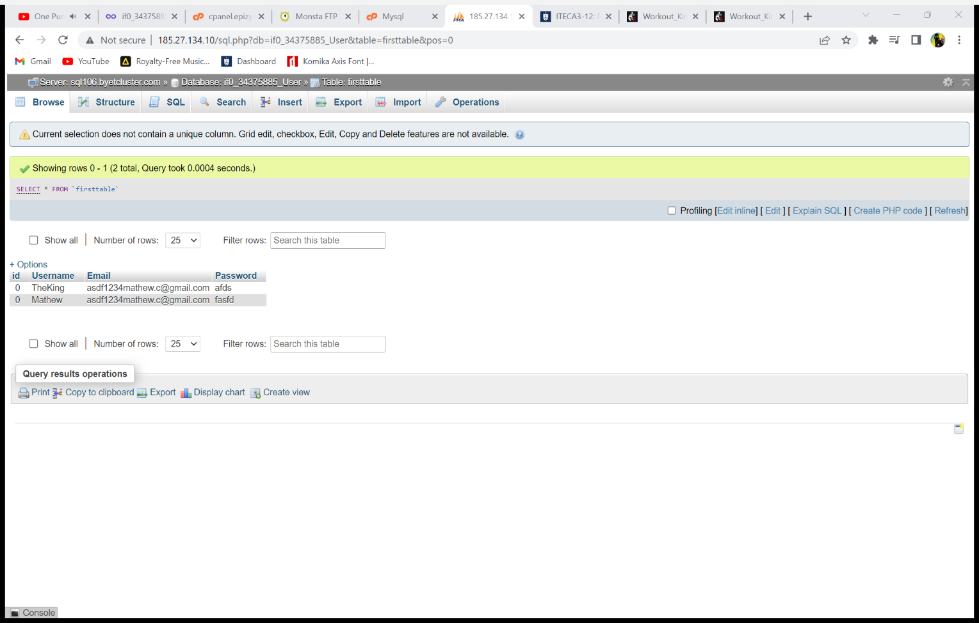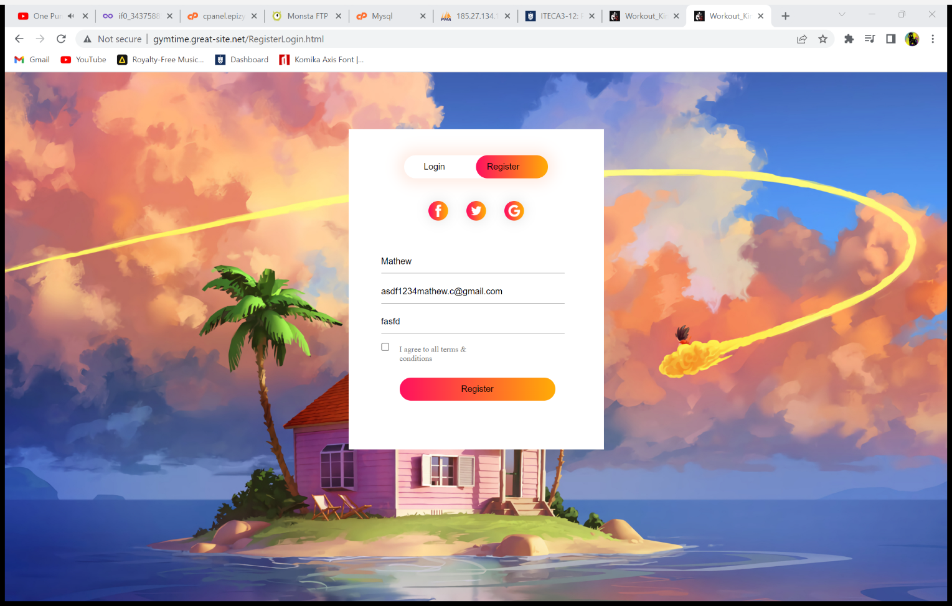

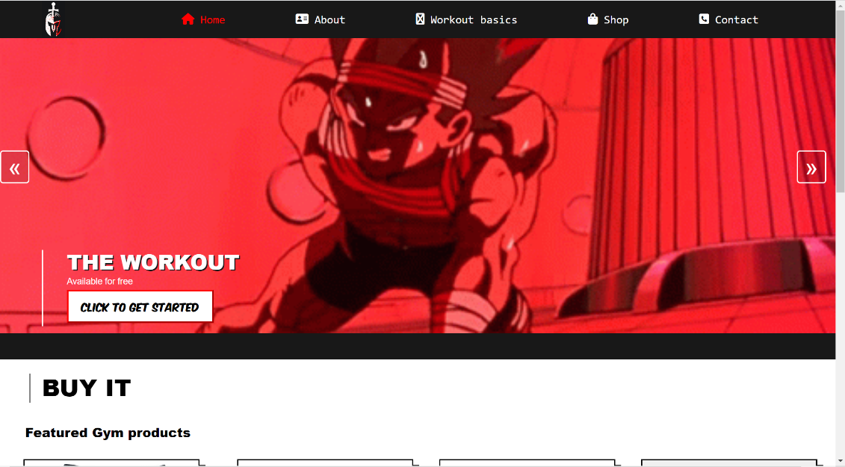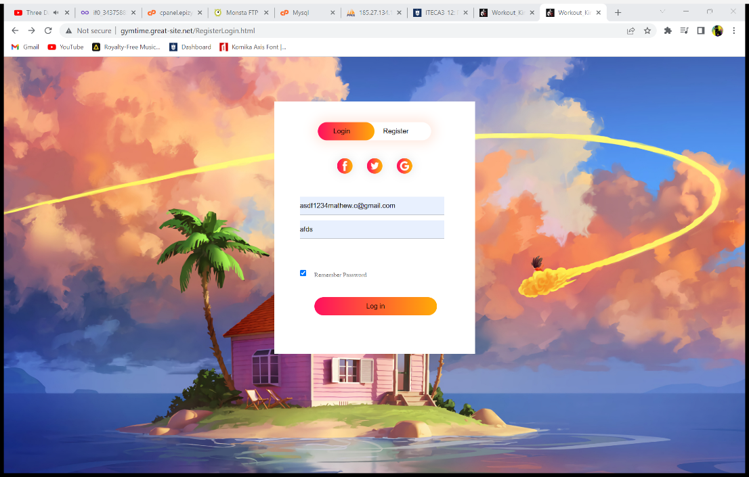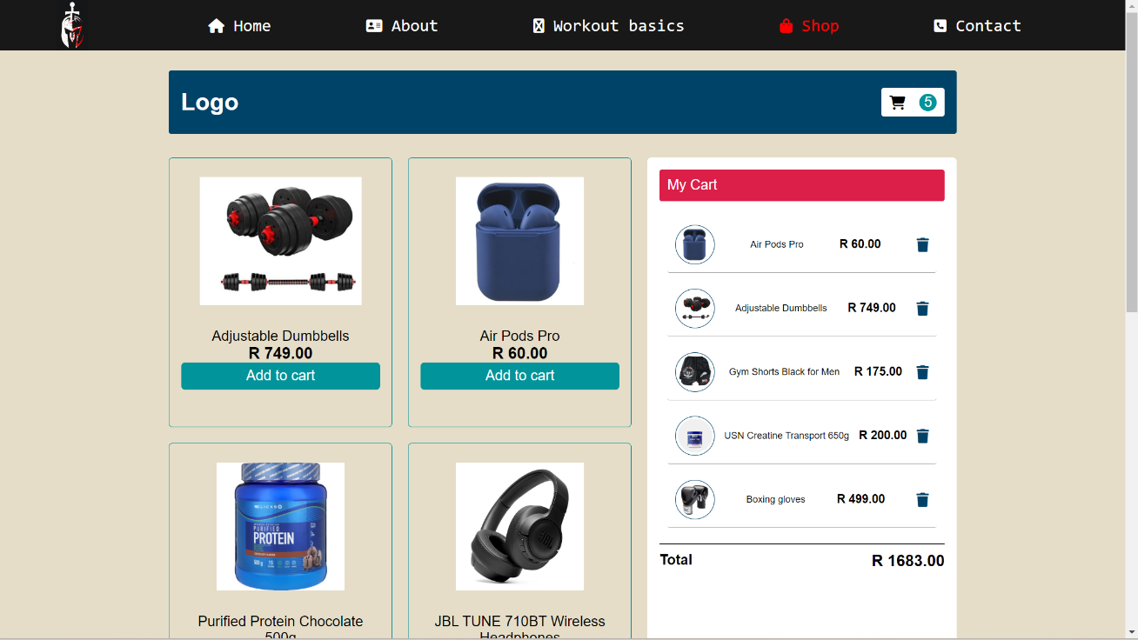

# Sample PHP Code

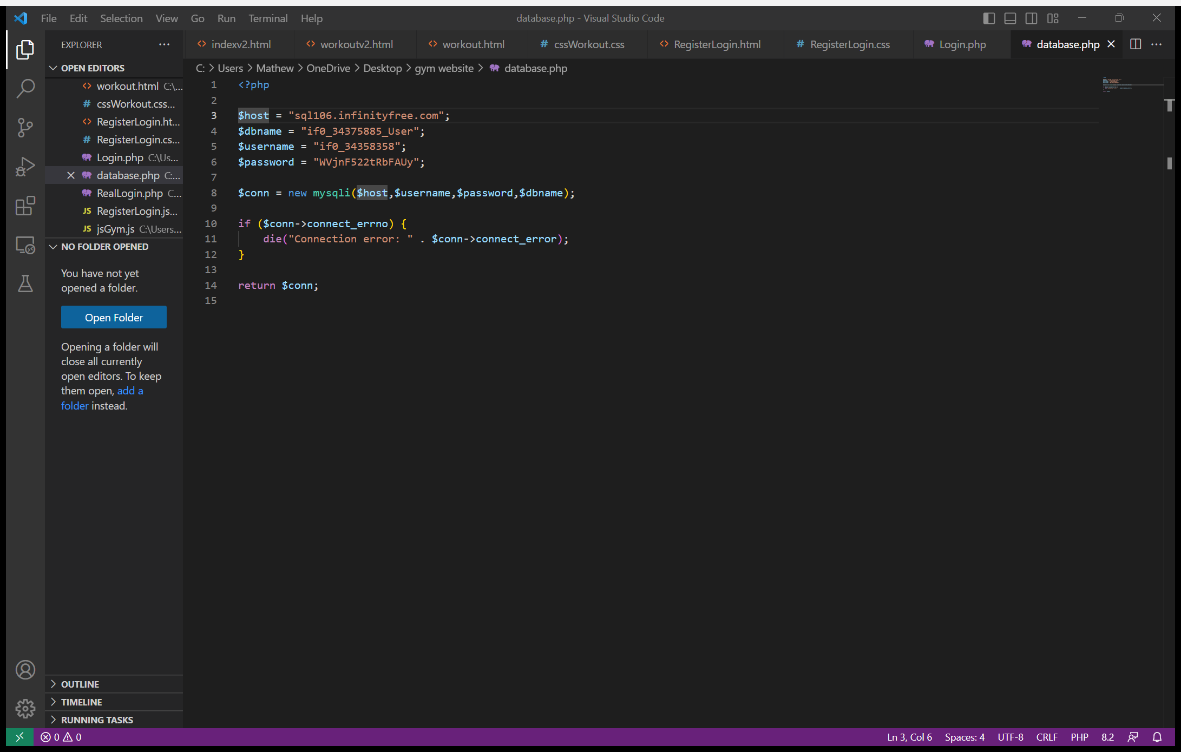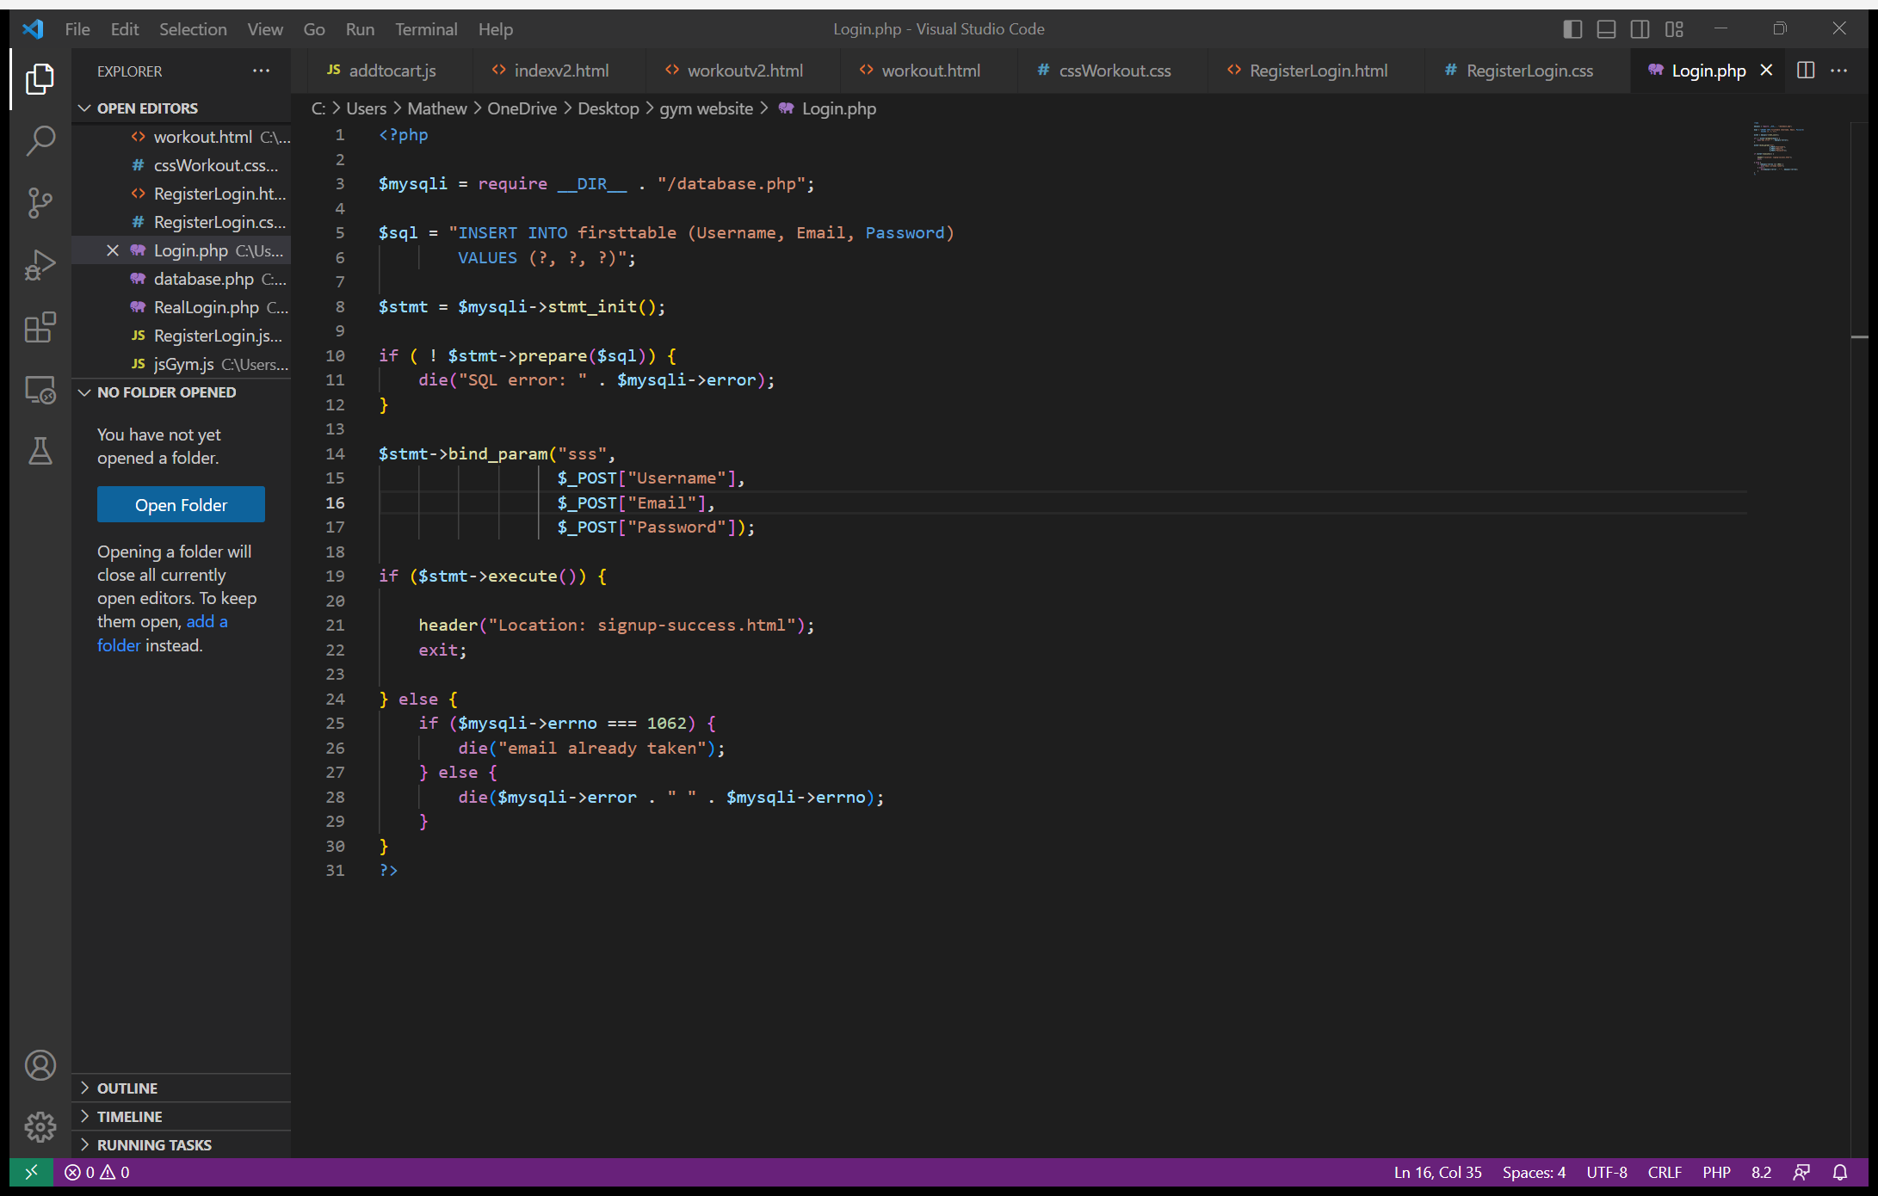

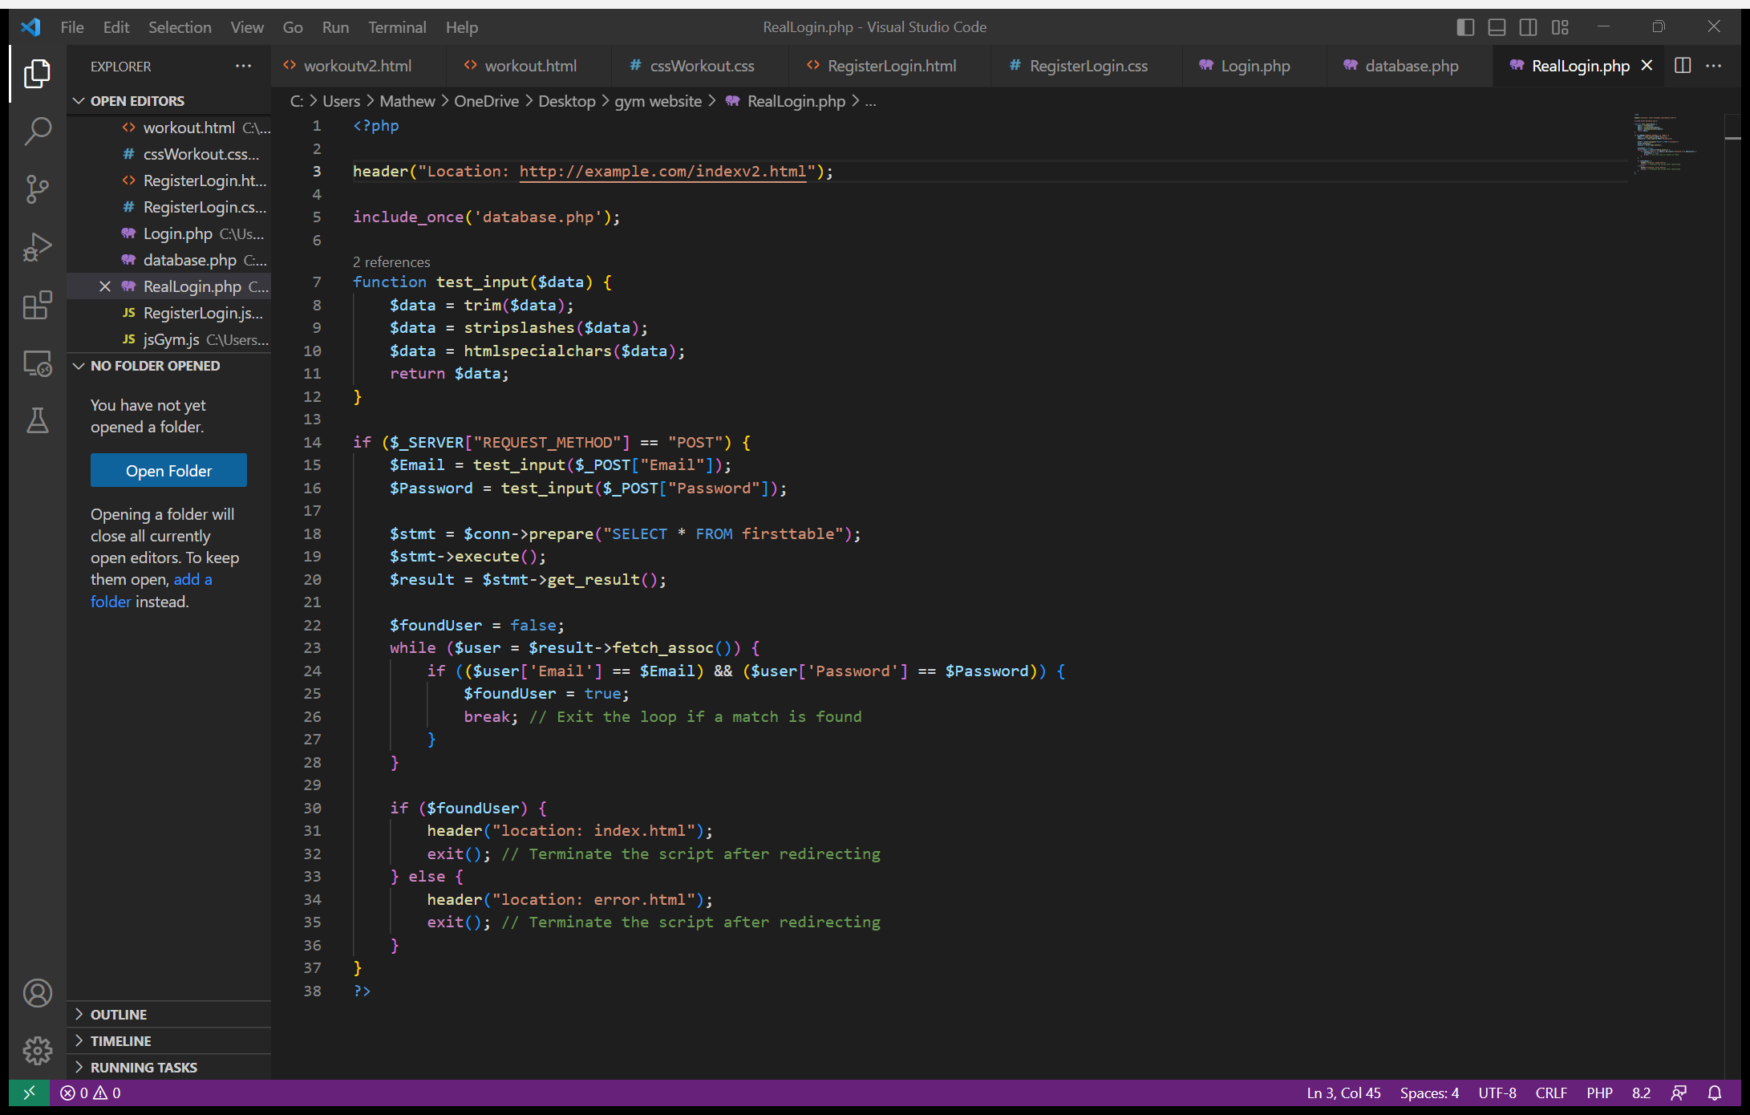

# Sample HTML Code Main page

<!DOCTYPE html>

<html>

    <head>

        <meta charset="utf-8">

        <title>Workout\_King</title>

        <meta name="viewport" content="width=device-width, initial-scale=1.0">

        <link rel="icon" type="images/x-icon" href="powerlogo.jpg" />

        <link rel="stylesheet" type="text/css" href="cssGym.css">

        <script src="jsGym.js" defer></script>

        <link rel="stylesheet" href="https://cdnjs.cloudflare.com/ajax/libs/font-awesome/6.4.0/css/all.min.css"/>

    </head>

    <body>

        <header>

            <a class="logo"><img src="powerlogo.jpg" height="70px" width="140px"></a>

            <ul class="navbar">

                <li><a href="index.html" class="active"><i class="fa fa-home"></i> Home</a></li>

                <li class="cu1"><a href="#T11"><i class="fa fa-address-card"></i> About </a></li>

                <li><a href="workout.html"><i class="fa fa-superpowers"></i> Workout basics </a></li>

                <li><a href="Shop.html"><i class="fa fa-shopping-bag"></i> Shop </a></li>

                <li class="cu2"><a href="#T11"><i class="fa fa-phone-square"></i> Contact</a></li>

            </ul>

            <div class="main">

                <a href="RegisterLogin.html" class="user"><i class="ri-user-fill"></i><i class="fa fa-sign-in"></i> Sign In</a>

                <a href="RegisterLogin.html" class="cu3"><i class="fa fa-user-plus"></i> Register</a>

            <div class="bx bx-menu" id="menu-icon"></div>

            </div>

        </header>

        <section aria-label="Newest Photos">

            <div class="carousel" data-carousel>

                <button class="carousel-button prev" data-carousel-button="prev">&#171;</button>

                <button class="carousel-button next" data-carousel-button="next">&#187;</button>

                <div class="vl"></div>

            <ul data-slides>

                <li class="slide" data-active>

                    <img src="vegeta.gif" alt="Workout page"/>

                    <a href="workout.html"><button class="bt11">CLICK TO GET STARTED</button></a>

                    <h1>THE WORKOUT</h1>

                    <p>Available for free</p>

                </li>

                <li class="slide">

                    <img src="Gymshop.jpg" alt="shop"/>

                    <a href="Shop.html"><button class="bt11">SHOP NOW</button></a>

                    <h1>THE SHOP</h1>

                    <p>10% off all protien products</p>

                </li>

                <li class="slide">

                    <img src="deku.gif" alt="about"/>

                    <a href="#T11"><button class="bt11">FIND OUT MORE</button></a>

                    <h1>ABOUT US</h1>

                    <p>Find out more about the company and what we stand for</p>

                </li>

            </ul>

            </div>

        </section>

        <div class="header2">

        </div>

        <h1 class="head1">BUY IT</h1>

        <div class="v2"></div>

        <h1 class="head2">Featured Gym products</h1>

        <div class="carousel" data-carousel>

            <a href="Shop.html"><button class="b1img"></button></a>

            <a href="Shop.html"><button class="b2img"></button></a>

            <a href="Shop.html"><button class="b3img"></button></a>

            <a href="Shop.html"><button class="b4img"></button></a>

            <a href="Shop.html"><button class="b5img"></button></a>

            <a href="Shop.html"><button class="b6img"></button></a>

            </div>

            <div class="header3"></div>

            <div class="header4">

                <img src="AboutUs.png"/>

                <h1 id="T11">ABOUT US</h1>

                <p class="p1">Workout Kings and Queens was founded in 2002 as a family owned and operated business specialising in supplying high-quality gym equipment at great prices.

                    Instead of being just another gym equipment retailer, our founders wanted to be the best in the industry and set their minds to doing so! Over the last two decades Gym and Fitness has grown into one of South Africa`s largest online fitness equipment retailers, helping thousands of customers live longer, happier and healthier lives.</p>

                <h2 id="T12">CONTACT</h2>

                <div class="social-icons">

                    <img src="facebook.png">

                    <img src="twitter.png">

                    <img src="instagram.png">

                </div>

                <p class="p2">Email: fakegmail@gmail.com <br><br> Number: 0000000000</p>

            </div>

            <div class="duh">

                <img  class="sizw" src="powerlogo.jpg"/><br>

                <p>&#169; 2023. All rights reserved. </p><br>

                <p>Terms of Service</p><br>

                <p>Privacy Policy</p><br>

                <p>Resources:</p><br>

                <p>Gym that you will never find</p><br>

            </div>

    </body>

</html>

## Shop html

<!DOCTYPE html>

<html>

<head>

  <title>Workout\_King</title>

  <link rel="icon" type="images/x-icon" href="powerlogo.jpg" />

  <link rel="stylesheet" href="cssShop.css">

  <link rel="stylesheet" href="https://cdnjs.cloudflare.com/ajax/libs/font-awesome/6.4.0/css/all.min.css"/>

</head>

<body>

    <header>

        <a class="logo"><img src="powerlogo.jpg" height="70px" width="140px"></a>

        <ul class="navbar">

            <li><a href="index.html"><i class="fa fa-home"></i> Home</a></li>

            <li class="cu3"><a href="index.html#T11"><i class="fa fa-address-card"></i> About </a></li>

            <li><a href="workout.html"><i class="fa fa-superpowers"></i> Workout basics </a></li>

            <li><a href="Shop.html" class="active"><i class="fa fa-shopping-bag"></i> Shop </a></li>

            <li class="cu3"><a href="index.html#T11"><i class="fa fa-phone-square"></i> Contact</a></li>

        </ul>

        <div class="main">

            <a href="RegisterLogin.html" class="user"><i class="ri-user-fill"></i><i class="fa fa-sign-in"></i> Sign In</a>

            <a href="RegisterLogin.html" class="cu3"><i class="fa fa-user-plus"></i> Register</a>

        <div class="bx bx-menu" id="menu-icon"></div>

        </div>

    </header>

    <div class="header2">

    </div>

  <div class="header3">

    <p class="logo">SHOP</p>

    <div class="cart"><i class="fas fa-shopping-cart"></i><p id="count">0</p></div>

  </div>

  <div class="container">

    <div id="root"></div>

    <div class="sidebar">

      <div class="head"><p>My Cart</p></div>

      <div id="cartItem" class="cartItem">Your cart is empty</div>

      <div class="foot">

        <h3>Total</h3>

        <h2 id="total">R 0.00</h2>

      </div>

    </div>

  </div>

  <script src="addtocart.js"></script>

</body>

</html>

## Workout html

<!DOCTYPE html>

<html>

    <head>

        <meta charset="utf-8">

        <title>Workout\_King</title>

        <link rel="icon" type="images/x-icon" href="powerlogo.jpg" />

        <link rel="stylesheet" type="text/css" href="cssWorkout.css">

        <link rel="stylesheet" href="https://cdnjs.cloudflare.com/ajax/libs/font-awesome/6.4.0/css/all.min.css"/>

    </head>

    <body>

        <header>

            <a class="logo"><img src="powerlogo.jpg" height="70px" width="140px"></a>

            <ul class="navbar">

                <li><a href="index.html"><i class="fa fa-home"></i> Home</a></li>

                <li class="cu3"><a href="index.html#T11"><i class="fa fa-address-card"></i> About </a></li>

                <li><a href="workout.html" class="active"><i class="fa fa-superpowers"></i> Workout basics </a></li>

                <li><a href="Shop.html"><i class="fa fa-shopping-bag"></i> Shop </a></li>

                <li class="cu3"><a href="index.html#T12"><i class="fa fa-phone-square"></i> Contact</a></li>

            </ul>

            <div class="main">

                <a href="RegisterLogin.html" class="user"><i class="ri-user-fill"></i><i class="fa fa-sign-in"></i> Sign In</a>

                <a href="RegisterLogin.html" class="cu3"><i class="fa fa-user-plus"></i> Register</a>

            <div class="bx bx-menu" id="menu-icon"></div>

            </div>

        </header>

        <div class="header2">

            <p >WORKOUT ROUTINE</p>

            <h2 class="head1">THE LOSE FAT AND GAIN MUSCLE WORKOUT PROGRAM</h2>

        </div>

        <div class="header3">

            <h1 class="head2">WITH WEIGHTS</h1>

        </div>

        <div class="whitebar"></div>

        <div class="header4">

            <h1 class="head3">FULL BODY</h1>

            <h1 class="head4">SHOP NOW</h1>

            <img src="Workoutprogram.jpg">

                <a href="Shop.html"><button class="b1img"></button></a>

                <a href="Shop.html"><button class="b2img"></button></a>

                <a href="Shop.html"><button class="b3img"></button></a>

        </div>

    </body>

</html>

## Register/login page

<html>

    <head>

        <title>Workout\_King</title>

        <link rel="icon" type="images/x-icon" href="powerlogo.jpg" />

        <link rel="stylesheet" href="RegisterLogin.css">

        <script src="RegisterLogin.js" defer></script>

    </head>

    <body>

        <div class="hero">

            <div class="form-box">

                <div class="button-box">

                    <div id="btn"></div>

                    <button type="button" class="toggle\_btn" onclick="Login()">Login</button>

                    <button type="button" class="toggle\_btn" onclick="Register()">Register</button>

                </div>

                <div class="social-icons">

                    <img src="fb.png">

                    <img src="tw.png">

                    <img src="gp.png">

                </div>

                <form id="Login" class="input-group" action="RealLogin.php" method="post">

                    <input type="text" class="input-field" placeholder="Email" required name="Email">

                    <input type="text" class="input-field" placeholder="Enter Password" required name="Password">

                    <input type="checkbox" class="chech-box">

                    <span>Remember Password</span>

                    <button type="submit" class="submit-btn">Log in</button>

                </form>

                <form id="Register" class="input-group" action="Login.php" method="post">

                    <input type="text" class="input-field" placeholder="User Name" required name="Username">

                    <input type="email" class="input-field" placeholder="Email" required name="Email">

                    <input type="text" class="input-field" placeholder="Enter Password" required name="Password">

                    <input type="checkbox" class="chech-box">

                    <span>I agree to all terms & conditions</span>

                    <button type="submit" class="submit-btn">Register</button>

                </form>

            </div>

        </div>

    </body>

</html>

# Sample JavaScript Code

## Add to cart

const product = [

      {

          id: 0,

          image: 'dumbellset.jpg',

          title: 'Adjustable Dumbbells',

          price: 749,

      },

      {

          id: 1,

          image: 'airpods.jpg',

          title: 'Air Pods Pro',

          price: 60

      },

      {

          id: 2,

          image: 'protienshake.jpg',

          title: 'Purified Protein Chocolate 500g',

          price: 230,

      },

      {

          id: 3,

          image: 'headphones.jpg',

          title: 'JBL TUNE 710BT Wireless Headphones',

          price: 1400,

      },

      {

        id: 0,

        image: 'creatine.jpg',

        title: 'USN Creatine Transport 650g',

        price: 200,

    },

    {

        id: 1,

        image: 'bakishorts.jpg',

        title: 'Gym Shorts Black for Men',

        price: 175

    },

    {

        id: 2,

        image: 'boxinggloves.jpg',

        title: 'Boxing gloves',

        price: 499,

    },

    ];

    function addtocart(id) {

      // Add your logic to handle adding the product to the cart

      console.log('Add to cart: ', id);

    }

    const categories = [...new Set(product.map((item) => item))];

    let i = 0;

    document.getElementById('root').innerHTML = categories.map((item) => {

      var { image, title, price } = item;

      return `

        <div class='box'>

          <div class='img-box'>

            <img class='images' src='${image}' alt='${title}'>

          </div>

          <div class='bottom'>

            <p>${title}</p>

            <h2>R ${price}.00</h2>

            <button onclick='addtocart(${i++})'>Add to cart</button>

          </div>

        </div>

      `;

    }).join('')

    var cart =[];

    function addtocart(a){

        cart.push({...categories[a]});

        displaycart();

    }

    function delElement(a){

        cart.splice(a, 1);

        displaycart();

    }

    function displaycart(a){

        let j = 0; total=0;

        document.getElementById("count").innerHTML=cart.length;

        if(cart.length==0){

            document.getElementById('cartItem').innerHTML = "Your cart is empty";

            document.getElementById("total").innerHTML = "R "+0+".00";

        }

        else{

            document.getElementById("cartItem").innerHTML = cart.map((items)=>

            {

                var{image, title, price} = items;

                total = total+price;

                document.getElementById("total").innerHTML = "R "+total+".00";

                return(

                    `<div class='cart-item'>

                    <div class='row-img'>

                        <img class='rowimg' src=${image}>

                    </div>

                    <p style='font-size:12px;'>${title}</p>

                    <h2 style='font-size: 15px;'>R ${price}.00</h2>`+

                    "<i class='fa-solid fa-trash' onclick='delElement("+(j++) +")'></i></div>"

                );

            }).join('');

        }

    }

## Register/Login

var x = document.getElementById("Login");

var y = document.getElementById("Register");

var z = document.getElementById("btn");

function Register(){

    x.style.left = "-400px";

    y.style.left = "50px";

    z.style.left = "110px";

}

function Login(){

    x.style.left = "50px";

    y.style.left = "450px";

    z.style.left = "0px";

}

## Main page

const buttons = document.querySelectorAll("[data-carousel-button]")

buttons.forEach(button =>{

    button.addEventListener("click", ()=> {

        const offset = button.CDATA\_SECTION\_NODE.carouselButton ==="next" ? 1:-1

        const slides = button

        .closest("[data-carousel]")

        .querySelector('[data-slides]')

        const activeSlide = slides.querySelector("[data-active]")

        let newIndex = [...slides.children].indexOf(activeSlide) + offset

        if (newIndex < 0) newIndex = slides.children.length - 1

        if (newIndex >= slides.children.length) newIndex = 0

        slides.children[newIndex].dataset.active = true

        delete activeSlide.dataset.active

    })

})

# Sample CSS Code

## Main page

body {

    background-color: #fff;

   }

\*{

    padding: 0;

    margin: 0;

    box-sizing: border-box;

    text-decoration: none;

    list-style: none;

}

:root{

    --bg-color: #000000;

    --text-color: #fff;

    --main-color: red;

}

header{

    background-color:#181818;

    overflow: hidden;

    position: fixed;

    width: 100%;

    height: 8%;

    top: 0;

    right: 0;

    z-index: 1000;

    display: flex;

    align-items: center;

    justify-content: space-between;

    padding: 5px 5%;

    transition: all .50s ease;

}

.header2{

    background-color:#181818;

    overflow: hidden;

    width: 100%;

    height: 45px;

    right: 0;

    z-index: 100;

    display: flex;

    align-items: center;

    padding: 1px 5%;

}

.header3{

    background-color:white;

    overflow: hidden;

    width: 100%;

    height: 400px;

    top: 10px;;

    right: 0;

    z-index: 100;

    display: flex;

    align-items: center;

    padding: 30px 5%;

}

.header4{

    position: absolute;

    background: linear-gradient(

        to right,

        #171717 0%,

        #171717 65%,

        #000000 35%,

        #000000 100%

      );

    width: 100%;

    height: 100px;

    top: 1500px;;

    right: 0;

    z-index: 100;

    display: flex;

    align-items: center;

    padding: 220px 5%;

}

.logo{

    width: 10px;

    height: 10px;

    display: flex;

    align-items: center;

    margin-right: 1px;

    padding: 5px 0;

    margin:0px 0px;

}

.navbar{

    display: flex;

}

.navbar a{

    font-family:monospace;

    color: var(--text-color);

    font-size: 1.2rem;

    font-weight: 500;

    padding: 5px 0;

    margin:0px 30px;

    transition: all .50s ease;

}

.navbar a:hover{

    color: var(--main-color);

}

.navbar a.active{

    color: var(--main-color);

}

.main{

    display: flex;

    align-items: center;

}

.main a{

    margin-right: 5px;

    margin-left: 40px;

    color: var(--text-color);

    font-size: 1.1rem;

    font-weight: 500;

    transition: all .50s ease;

}

\*,\*::before, \*::after{

    box-sizing: border-box;

}

.carousel{

    width: 100%;

    height: 70vh;

    position: relative;

}

.carousel > ul{

    margin: 0;

    padding: 0;

    list-style: none;

}

.slide{

    position: absolute;

    inset: 0;

    opacity: 0;

    transition: 200ms opacity ease-in-out;

    transition-delay: 200ms;

}

.slide >img{

    display: block;

    width: 100%;

    height: 100%;

    object-fit: cover;

    object-position: center;

}

.slide >p{

    width: 400px;

    height: 10%;

    position: absolute;

    top: 83%;

    left: 8%;

    color: white;

    font-family: 'Falling Sky', sans-serif;

    font-size: 15px;

    stroke: 2px 2px #000000;

}

.slide >h1{

    width: 400px;

    height: 10%;

    position: absolute;

    top: 74%;

    left: 8%;

    color: white;

    font-family: 'Trueno', sans-serif;

    font-weight: 800;

    font-size: 35px;

    text-shadow: 2px 2px #181818;

}

.bt11{

    display:ruby-base;

    width: 250px;

    height: 10%;

    position: absolute;

    top: 87%;

    left: 8%;

    cursor: pointer;

    background-color:var(--text-color);

    color: black;

    border-width: 3px;

    border-color: var(--main-color);

    font-family: 'Komika Axis', sans-serif;

    font-size: 17px;

}

.slide > button:hover,

.slide > button:focus{

    color: var(--main-color);

    background-color: rgba(0, 0, 0, .2);

    border-color: var(--main-color);

}

.slide[data-active]{

    opacity: 1;

    z-index: 1;

    transition-delay: 0ms;

}

.carousel-button{

    width: 50px;

    font-family: Arial, Helvetica;

    position: absolute;

    z-index: 2;

    background: none;

    border: 2px solid #fff;

    font-size: 40px;

    top: 50%;

    transform: translateY(-50%);

    color: white;

    cursor: pointer;

    border-radius: 10%;

    padding: 0.2rem;

    background-color: rgba(0, 0, 0, .1);

}

.carousel-button:hover,

.carousel-button:focus{

    color: var(--main-color);

    background-color: rgba(0, 0, 0, .2);

    border-color: var(--main-color);

}

.carousel-button:focus{

    outline: 1px solid black;

}

.carousel-button.next{

    right: 1rem;

    shape-margin: 0%;

}

.vl {

    border-left: 2px solid white;

    height: 130px;

    width: 1px;

    position: absolute;

    z-index: 2;

    top: 75%;

    left: 5%;

    color: white;

    padding: 0.2rem;

  }

.v2{

    border-left: 2px solid gray;

    height: 50px;

    width: 1px;

    position: absolute;

    z-index: 2;

    top: 635px;

    left: 50px;

    color: white;

    padding: 0.2rem;

}

.b1{

    top: 20px;

    align-items: center;

    margin-right: 0px;

    margin-left: 0px;

    color: var(--text-color);

    font-size: 1.1rem;

    font-weight: 500;

    padding: 32px 0px;

  }

.b2{

    align-items: center;

    margin-right: 800px;

    margin-left: 0px;

    color: var(--text-color);

    font-size: 1.1rem;

    font-weight: 500;

    padding: 32px 0px;

}

.head1{

    width: 400px;

    position: absolute;

    top: 630px;

    left: 5%;

    color: #000000;

    font-family: 'Trueno', sans-serif;

    font-weight: 800;

    font-size: 40px;

}

.head2{

    width: 400px;

    position: absolute;

    top: 720px;

    left: 3%;

    color: #000000;

    font-family: 'Trueno', sans-serif;

    font-weight: 800;

    font-size: 22px;

}

.b1img{

    margin: auto;

    position: relative;

    height: 300px;

    width: 300px;

    font-family: Arial, Helvetica;

    z-index: 2;

    background:url(bakishorts.jpg);

    border: 2px solid black;

    font-size: 40px;

    top: 170px;

    left: 40px;

    cursor: pointer;

    padding: 0.2rem;

    background-size: cover;

    box-shadow: 10px 10px #000000;

}

.b1img:hover {background-color: #3e8e41}

.b1img:active {

  background-color: #3e8e41;

  box-shadow: 0 5px #666;

  transform: translateY(4px);

}

.b2img{

    margin: auto;

    position: relative;

    height: 300px;

    width: 300px;

    font-family: Arial, Helvetica;

    z-index: 2;

    background:url(dumbellset.jpg);

    border: 2px solid black;

    font-size: 40px;

    top: 170px;

    left: 100px;

    cursor: pointer;

    padding: 0.2rem;

    background-size: cover;

    box-shadow: 10px 10px #000000;

    object-fit: cover

}

.b2img:hover {background-color: #3e8e41}

.b2img:active {

  background-color: #3e8e41;

  box-shadow: 0 5px #666;

  transform: translateY(4px);

}

.b3img{

    margin: auto;

    position: relative;

    height: 300px;

    width: 300px;

    font-family: Arial, Helvetica;

    z-index: 2;

    background:url(headphones.jpg);

    border: 2px solid black;

    font-size: 40px;

    top: 170px;

    left: 140px;

    cursor: pointer;

    padding: 0.2rem;

    background-size: cover;

    box-shadow: 10px 10px #000000;

}

.b3img:hover {background-color: #3e8e41}

.b3img:active {

  background-color: #3e8e41;

  box-shadow: 0 5px #666;

  transform: translateY(4px);

}

.b4img{

    margin: auto;

    position: relative;

    height: 300px;

    width: 300px;

    font-family: Arial, Helvetica;

    z-index: 2;

    background:url(creatine.jpg);

    border: 2px solid black;

    font-size: 40px;

    top: 170px;

    left: 180px;

    cursor: pointer;

    padding: 0.2rem;

    background-size: cover;

    box-shadow: 10px 10px #000000;

}

.b4img:hover {background-color: #3e8e41}

.b4img:active {

  background-color: #3e8e41;

  box-shadow: 0 5px #666;

  transform: translateY(4px);

}

.b5img{

    margin: auto;

    position: relative;

    height: 300px;

    width: 300px;

    font-family: Arial, Helvetica;

    z-index: 2;

    background:url(airpods.jpg);

    border: 2px solid black;

    font-size: 40px;

    top: 220px;

    left: 40px;

    cursor: pointer;

    padding: 0.2rem;

    background-size: cover;

    box-shadow: 10px 10px #000000;

}

.b5img:hover {background-color: #3e8e41}

.b5img:active {

  background-color: #3e8e41;

  box-shadow: 0 5px #666;

  transform: translateY(4px);

}

.b6img{

    margin: auto;

    position: relative;

    height: 300px;

    width: 300px;

    font-family: Arial, Helvetica;

    z-index: 2;

    background:url(boxinggloves.jpg);

    border: 2px solid black;

    font-size: 40px;

    top: 220px;

    left: 100px;

    cursor: pointer;

    padding: 0.2rem;

    background-size: cover;

    box-shadow: 10px 10px #000000;

}

.b6img:hover {background-color: #3e8e41}

.b6img:active {

  background-color: #3e8e41;

  box-shadow: 0 5px #666;

  transform: translateY(4px);

}

.header4 >img{

    margin-left: -20px;

    width: 300px;

    height: 370px;

    top:20px;

    left:20px;

    object-fit: cover

}

.header4 >h1{

    position: absolute;

    top: 20px;

    left: 30%;

    color: var(--text-color);

    font-family: 'Trueno', sans-serif;

    font-weight: 700;

    font-size: 40px;

    text-shadow: 2px 2px #000000;

}

.p1{

    position: absolute;

    top: 80px;

    left: 30%;

    width: 500px;

    color: #fff;

}

.header4 >h2{

    position: absolute;

    top: 20px;

    left: 68%;

    color: var(--text-color);

    font-family: 'Trueno', sans-serif;

    font-weight: 700;

    font-size: 40px;

    text-shadow: 2px 2px #000000;

}

.p2{

    position: absolute;

    top: 120px;

    left: 68%;

    width: 500px;

    color: #fff;

}

.duh{

    position: absolute;

    left: 50%;

    top: 1950px;

    z-index: 100;

}

.sizw{

    position: absolute;

    top: 20px;

    left: -100%;

    height: 150px;

    width: 100px;

}

.duh p{

    top: 50px;

    text-align: center;

}

.social-icons{

    margin: 30px auto;

}

.social-icons img{

    position: relative;

    top: -125px;

    left: 190px;

    width: 30px;

    margin: 0 12px;

    box-shadow: 0 0 20px 0 #7f7f7f3d;

    cursor: pointer;

    border-radius: 0%;

}

.textclass{

    top: 10px;

}

@media only screen and (max-width: 1190px){

    .cu1{

        display: none;

    }

    .cu2{

        display: none;

    }

    .cu3{

        display: none;

    }

    .v2{

        border-left: 2px solid gray;

        height: 50px;

        width: 1px;

        position: absolute;

        z-index: 2;

        top: 635px;

        left: 10px;

        color: white;

        padding: 0.2rem;

    }

    .b1img{

        margin: auto;

        position: relative;

        height: 200px;

        width: 200px;

        font-family: Arial, Helvetica;

        z-index: 2;

        background:url(bakishorts.jpg);

        border: 2px solid black;

        top: 180px;

        left: 10px;

        cursor: pointer;

        padding: 0.2rem;

        background-size: cover;

        box-shadow: 10px 10px #000000;

    }

    .b2img{

        margin: auto;

        position: relative;

        height: 200px;

        width: 200px;

        font-family: Arial, Helvetica;

        z-index: 2;

        background:url(dumbellset.jpg);

        border: 2px solid black;

        top: 180px;

        left: 50px;

        cursor: pointer;

        padding: 0.2rem;

        background-size: cover;

        box-shadow: 10px 10px #000000;

    }

    .b3img{

        margin: auto;

        position: relative;

        height: 200px;

        width: 200px;

        font-family: Arial, Helvetica;

        z-index: 2;

        background:url(headphones.jpg);

        border: 2px solid black;

        top: 410px;

        left: -400px;

        cursor: pointer;

        padding: 0.2rem;

        background-size: cover;

        box-shadow: 10px 10px #000000;

    }

    .b4img{

        margin: auto;

        position: relative;

        height: 200px;

        width: 200px;

        font-family: Arial, Helvetica;

        z-index: 2;

        background:url(airpods.jpg);

        border: 2px solid black;

        top: 210px;

        left: 255px;

        cursor: pointer;

        padding: 0.2rem;

        background-size: cover;

        box-shadow: 10px 10px #000000;

    }

    .b5img{

        margin: auto;

        position: relative;

        height: 200px;

        width: 200px;

        font-family: Arial, Helvetica;

        z-index: 2;

        background:url(creatine.jpg);

        border: 2px solid black;

        top: 450px;

        left: -197px;

        cursor: pointer;

        padding: 0.2rem;

        background-size: cover;

        box-shadow: 10px 10px #000000;

    }

    .b6img{

        margin: auto;

        position: relative;

        height: 200px;

        width: 200px;

        font-family: Arial, Helvetica;

        z-index: 2;

        background:url(boxinggloves.jpg);

        border: 2px solid black;

        top: 450px;

        left: -150px;

        cursor: pointer;

        padding: 0.2rem;

        background-size: cover;

        box-shadow: 10px 10px #000000;

    }

    .header4{

        position: absolute;

        background: linear-gradient(

            to right,

            #171717 0%,

            #171717 65%,

            #000000 35%,

            #000000 100%

          );

        width: 100%;

        height: 100px;

        top: 1500px;;

        right: 0;

        z-index: 100;

        display: flex;

        align-items: center;

        padding: 120px 5%;

    }

    .header4 >img{

        margin-left: -20px;

        width: 130px;

        height: 170px;

        top:20px;

        left:20px;

        object-fit: cover

    }

    .header4 >h1{

        position: absolute;

        top: 20px;

        left: 30%;

        color: var(--text-color);

        font-family: 'Trueno', sans-serif;

        font-weight: 700;

        font-size: 20px;

        text-shadow: 2px 2px #000000;

    }

    .p1{

        font-size: 10px;

        position: absolute;

        top: 50px;

        left: 30%;

        width: 180px;

        color: #fff;

    }

    .header4 >h2{

        position: absolute;

        top: 20px;

        left: 68%;

        color: var(--text-color);

        font-family: 'Trueno', sans-serif;

        font-weight: 700;

        font-size: 20px;

        text-shadow: 2px 2px #000000;

    }

    .p2{

        font-size: 10px;

        position: absolute;

        top: 100px;

        left: 68%;

        width: 500px;

        color: #fff;

    }

    .social-icons{

        margin: 30px auto;

    }

    .social-icons img{

        position: relative;

        top: -55px;

        left: 110px;

        width: 15px;

        margin: 0 12px;

        box-shadow: 0 0 20px 0 #7f7f7f3d;

        cursor: pointer;

        border-radius: 0%;

    }

    .duh p{

        position: relative;

        top: 0px;

        text-align: center;

    }

    .navbar a{

        font-family:monospace;

        color: var(--text-color);

        font-size: 0.9rem;

        font-weight: 500;

        padding: 5px 0;

        margin:0px 20px;

        transition: all .50s ease;

    }

    .main a{

        margin-right: 5px;

        margin-left: 40px;

        color: var(--text-color);

        font-size: 0.9rem;

        font-weight: 500;

        transition: all .50s ease;

    }

}

## Shop page

\*{

    padding: 0;

    margin: 0;

    box-sizing: border-box;

    text-decoration: none;

    list-style: none;

}

:root{

    --bg-color: #000000;

    --text-color: #fff;

    --main-color: red;

}

header{

    background-color:#181818;

    overflow: hidden;

    position: fixed;

    width: 100%;

    height: 8%;

    top: 0;

    right: 0;

    z-index: 1000;

    display: flex;

    align-items: center;

    justify-content: space-between;

    padding: 5px 5%;

    transition: all .50s ease;

}

.logo{

    width: 10px;

    height: 10px;

    display: flex;

    align-items: center;

    margin-right: 1px;

    padding: 5px 0;

    margin:0px 0px;

}

.navbar{

    display: flex;

}

.navbar a{

    font-family:monospace;

    color: var(--text-color);

    font-size: 1.1rem;

    font-weight: 500;

    padding: 5px 0;

    margin:0px 30px;

    transition: all .50s ease;

}

.navbar a:hover{

    color: var(--main-color);

}

.navbar a.active{

    color: var(--main-color);

}

.main{

    display: flex;

    align-items: center;

}

.main a{

    margin-right: 5px;

    margin-left: 40px;

    color: var(--text-color);

    font-size: 0.7 rem;

    font-weight: 500;

    transition: all .50s ease;

}

\*,\*::before, \*::after{

    box-sizing: border-box;

}

\*{

    margin: 0;

    padding: 0;

    box-sizing: border-box;

    font-family: 'poppins', sans-serif;

    font-size: 18px;

}

body{

    background-color: #E5DDC8;

    display: flex;

    align-items: center;

    justify-content: center;

    flex-direction: column;

}

.header3{

    height: 80px;

    width:70%;

    background-color: #004369;

    border-radius: 3px;

    margin: 30px 0px;

    display: flex;

    align-items: center;

    justify-content: space-between;

    padding: 15px;

}

.header3 .logo{

    font-size: 30px;

    font-weight: bold;

    color: white;

}

.cart{

    display: flex;

    background-color: white;

    justify-content: space-between;

    align-items: center;

    padding: 7px 10px;

    border-radius: 3px;

    width: 80px;

}

.fa-solid{

    color: #004369;

}

.cart p{

    height: 22px;

    width: 22px;

    display: flex;

    align-items: center;

    justify-content: center;

    border-radius: 22px;

    background-color: #01949A;

    color: white;

}

.container{

    display: flex;

    width: 70%;

    margin-bottom: 30px;

}

#root{

    width: 60%;

    display: grid;

    grid-template-columns: repeat(2, 1fr);

    grid-gap: 20px;

}

.sidebar{

    background-color: #000000;

    width: 40%;

    border-radius: 5px;

    background-color: white;

    margin-left: 20px;

    padding: 15px;

    text-align: center;

}

.head{

    background-color: #DB1F48;

    border-radius: 3px;

    height: 40px;

    padding: 10px;

    margin-bottom: 20px;

    color: white;

    display: flex;

    align-items: center;

}

.foot{

    display: flex;

    justify-content: space-between;

    margin: 20px 0px;

    padding: 10px 0px;

    border-top: 1px solid;

}

.box{

    display: flex;

    flex-direction: column;

    align-items: center;

    justify-content: space-between;

    border: 1px solid #01949A;

    border-radius: 5px;

    padding: 5px;

}

.img-box{

    width: 100%;

    height: 180px;

    display: flex;

    align-items: center;

    justify-content: center;

}

.images{

    max-width: 90%;

    max-height: 90%;

    object-fit: cover;

    object-fit: cover;

    object-position: center;

}

.bottom{

    margin-top: 20px;

    width: 100%;

    text-align: center;

    display: flex;

    flex-direction: column;

    align-items: center;

    justify-items: space-between;

    height: 110px;

}

h2{

    font-size: 20px;

    color: black;

}

button{

    width: 100%;

    position: relative;

    border: none;

    border-radius: 5px;

    background-color: #01949A;

    padding: 7px 25px;

    cursor: pointer;

    color:white;

}

button:hover{

    background-color: #333;

}

.cart-item{

    display: flex;

    align-items: center;

    justify-content: space-between;

    padding: 10px;

    background-color: white;

    border-bottom: 1px solid #aaa;

    border-radius: 3px;

    margin: 10px 10px;

}

.row-img{

    width: 50px;

    height: 50px;

    border-radius: 50px;

    border: 1px solid #004369;

    display: flex;

    align-items: center;

    justify-content: center;

}

.rowimg{

    max-width: 43px;

    max-height: 43px;

    border-radius: 50%;

}

.fa-trash:hover{

    cursor: pointer;

    color: #333;

}

.header2{

    background-color:gray;

    overflow: hidden;

    width: 100%;

    height: 40px;

    top: 10px;;

    right: 0;

    z-index: 100;

    display: flex;

    align-items: center;

    padding: 30px 5%;

}

@media only screen and (max-width: 1190px){

    .cu1{

        display: none;

    }

    .cu2{

        display: none;

    }

    .cu3{

        display: none;

    }

    .v2{

        border-left: 2px solid gray;

        height: 50px;

        width: 1px;

        position: absolute;

        z-index: 2;

        top: 635px;

        left: 10px;

        color: white;

        padding: 0.2rem;

    }

    .b1img{

        margin: auto;

        position: relative;

        height: 200px;

        width: 200px;

        font-family: Arial, Helvetica;

        z-index: 2;

        background:url(bakishorts.jpg);

        border: 2px solid black;

        top: 180px;

        left: 10px;

        cursor: pointer;

        padding: 0.2rem;

        background-size: cover;

        box-shadow: 10px 10px #000000;

    }

    .b2img{

        margin: auto;

        position: relative;

        height: 200px;

        width: 200px;

        font-family: Arial, Helvetica;

        z-index: 2;

        background:url(dumbellset.jpg);

        border: 2px solid black;

        top: 180px;

        left: 50px;

        cursor: pointer;

        padding: 0.2rem;

        background-size: cover;

        box-shadow: 10px 10px #000000;

    }

    .b3img{

        margin: auto;

        position: relative;

        height: 200px;

        width: 200px;

        font-family: Arial, Helvetica;

        z-index: 2;

        background:url(headphones.jpg);

        border: 2px solid black;

        top: 410px;

        left: -400px;

        cursor: pointer;

        padding: 0.2rem;

        background-size: cover;

        box-shadow: 10px 10px #000000;

    }

    .b4img{

        margin: auto;

        position: relative;

        height: 200px;

        width: 200px;

        font-family: Arial, Helvetica;

        z-index: 2;

        background:url(airpods.jpg);

        border: 2px solid black;

        top: 210px;

        left: 255px;

        cursor: pointer;

        padding: 0.2rem;

        background-size: cover;

        box-shadow: 10px 10px #000000;

    }

    .b5img{

        margin: auto;

        position: relative;

        height: 200px;

        width: 200px;

        font-family: Arial, Helvetica;

        z-index: 2;

        background:url(creatine.jpg);

        border: 2px solid black;

        top: 450px;

        left: -197px;

        cursor: pointer;

        padding: 0.2rem;

        background-size: cover;

        box-shadow: 10px 10px #000000;

    }

    .b6img{

        margin: auto;

        position: relative;

        height: 200px;

        width: 200px;

        font-family: Arial, Helvetica;

        z-index: 2;

        background:url(boxinggloves.jpg);

        border: 2px solid black;

        top: 450px;

        left: -150px;

        cursor: pointer;

        padding: 0.2rem;

        background-size: cover;

        box-shadow: 10px 10px #000000;

    }

    .header4{

        position: absolute;

        background: linear-gradient(

            to right,

            #171717 0%,

            #171717 65%,

            #000000 35%,

            #000000 100%

          );

        width: 100%;

        height: 100px;

        top: 1500px;;

        right: 0;

        z-index: 100;

        display: flex;

        align-items: center;

        padding: 120px 5%;

    }

    .header4 >img{

        margin-left: -20px;

        width: 130px;

        height: 170px;

        top:20px;

        left:20px;

        object-fit: cover

    }

    .header4 >h1{

        position: absolute;

        top: 20px;

        left: 30%;

        color: var(--text-color);

        font-family: 'Trueno', sans-serif;

        font-weight: 700;

        font-size: 20px;

        text-shadow: 2px 2px #000000;

    }

    .p1{

        font-size: 10px;

        position: absolute;

        top: 50px;

        left: 30%;

        width: 180px;

        color: #fff;

    }

    .header4 >h2{

        position: absolute;

        top: 20px;

        left: 68%;

        color: var(--text-color);

        font-family: 'Trueno', sans-serif;

        font-weight: 700;

        font-size: 20px;

        text-shadow: 2px 2px #000000;

    }

    .p2{

        font-size: 10px;

        position: absolute;

        top: 100px;

        left: 68%;

        width: 500px;

        color: #fff;

    }

    .social-icons{

        margin: 30px auto;

    }

    .social-icons img{

        position: relative;

        top: -55px;

        left: 110px;

        width: 15px;

        margin: 0 12px;

        box-shadow: 0 0 20px 0 #7f7f7f3d;

        cursor: pointer;

        border-radius: 0%;

    }

    .duh p{

        position: relative;

        top: 0px;

        text-align: center;

    }

    .navbar a{

        font-family:monospace;

        color: var(--text-color);

        font-size: 0.9rem;

        font-weight: 500;

        padding: 5px 0;

        margin:0px 20px;

        transition: all .50s ease;

    }

    .main a{

        margin-right: 5px;

        margin-left: 40px;

        color: var(--text-color);

        font-size: 0.9rem;

        font-weight: 500;

        transition: all .50s ease;

    }

    h2{

        font-size: 15px;

        color: black;

    }

    button{

        width: 100%;

        position: relative;

        border: none;

        border-radius: 5px;

        background-color: #01949A;

        padding: 5px 5px;

        cursor: pointer;

        color:white;

    }

    .img-box{

        width: 100%;

        height: 80px;

        display: flex;

        align-items: center;

        justify-content: center;

    }

    p{

        font-size: 14px;

    }

    .sidebar{

        background-color: #000000;

        width: 50%;

        border-radius: 5px;

        background-color: white;

        margin-left: 20px;

        padding: 15px;

        text-align: center;

    }

}

## Workout

body {

    background-color: #fff;

   }

\*{

    padding: 0;

    margin: 0;

    box-sizing: border-box;

    text-decoration: none;

    list-style: none;

}

:root{

    --bg-color: #000000;

    --text-color: #fff;

    --main-color: red;

}

header{

    background-color:#181818;

    overflow: hidden;

    position: fixed;

    width: 100%;

    height: 8%;

    top: 0;

    right: 0;

    z-index: 1000;

    display: flex;

    align-items: center;

    justify-content: space-between;

    padding: 5px 5%;

    transition: all .50s ease;

}

.logo{

    width: 10px;

    height: 10px;

    display: flex;

    align-items: center;

    margin-right: 1px;

    padding: 5px 0;

    margin:0px 0px;

}

.navbar{

    display: flex;

}

.navbar a{

    font-family:monospace;

    color: var(--text-color);

    font-size: 1.2rem;

    font-weight: 500;

    padding: 5px 0;

    margin:0px 30px;

    transition: all .50s ease;

}

.navbar a:hover{

    color: var(--main-color);

}

.navbar a.active{

    color: var(--main-color);

}

.main{

    display: flex;

    align-items: center;

}

.main a{

    margin-right: 5px;

    margin-left: 40px;

    color: var(--text-color);

    font-size: 1.1rem;

    font-weight: 500;

    transition: all .50s ease;

}

\*,\*::before, \*::after{

    box-sizing: border-box;

}

.header2 {

    margin-left: 40px;

    position: relative;

    top: 100px;

    height: 200px;

    background-color: #fff;

  }

.head1{

    width: 70%;

    margin-left: 0%;

    align-items: center;

    color: #181818;

    font-family: 'Trueno', sans-serif;

    font-weight: 600;

    font-size: 50px;

}

.header3 {

    position: relative;

    top: 70px;

    height: 100px;

    background-color: #A30000;

  }

.head2{

    position: relative;

    top: 30px;

    left: 70px;

    width: 70%;

    margin-left: 0%;

    align-items: center;

    color: #fff;

    font-family: 'nfl-detroit-lions-regular', sans-serif;

    font-weight:600;

    font-size: 40px;

}

.header4 {

    position: relative;

    top: 70px;

    height: 1000px;

    background-color: #2E2E2E;

  }

.header4 img{

    position: relative;

    top: 50px;

    left: 70px;

    width: 60%;

    margin-left: 0%;

    align-items: center;

}

.head3{

    position: relative;

    top: 30px;

    left: 70px;

    width: 70%;

    margin-left: 0%;

    align-items: center;

    color: #fff;

    font-family: 'nfl-detroit-lions-regular', sans-serif;

    font-weight:400;

    font-size: 40px;

}

.head4{

    position: relative;

    top: 30px;

    left: 1050px;

    width: 70%;

    margin-left: 0%;

    align-items: center;

    color: peru;

    font-family: 'Komika Axis', sans-serif;

    font-weight:400;

    font-size: 40px;

}

.whitebar{

    position: relative;

    top: 70px;

    height: 10px;

    background-color: #fff;

}

.b1img{

    margin: auto;

    position: relative;

    height: 200px;

    width: 200px;

    font-family: Arial, Helvetica;

    z-index: 2;

    background:url(bakishorts.jpg);

    border: 2px solid black;

    font-size: 40px;

    top: -500px;

    left: 200px;

    cursor: pointer;

    padding: 0.2rem;

    background-size: cover;

    box-shadow: 10px 10px #000000;

}

.b1img:hover {background-color: #3e8e41}

.b1img:active {

  background-color: #3e8e41;

  box-shadow: 0 5px #666;

  transform: translateY(4px);

}

.b2img{

    margin: auto;

    position: relative;

    height: 200px;

    width: 200px;

    font-family: Arial, Helvetica;

    z-index: 2;

    background:url(dumbellset.jpg);

    border: 2px solid black;

    font-size: 40px;

    top: -250px;

    left: 0px;

    cursor: pointer;

    padding: 0.2rem;

    background-size: cover;

    box-shadow: 10px 10px #000000;

    object-fit: cover

}

.b2img:hover {background-color: #3e8e41}

.b2img:active {

  background-color: #3e8e41;

  box-shadow: 0 5px #666;

  transform: translateY(4px);

}

.b3img{

    margin: auto;

    position: relative;

    height: 200px;

    width: 200px;

    font-family: Arial, Helvetica;

    z-index: 2;

    background:url(headphones.jpg);

    border: 2px solid black;

    font-size: 40px;

    top: -200px;

    left: 1062px;

    cursor: pointer;

    padding: 0.2rem;

    background-size: cover;

    box-shadow: 10px 10px #000000;

}

.b3img:hover {background-color: #3e8e41}

.b3img:active {

  background-color: #3e8e41;

  box-shadow: 0 5px #666;

  transform: translateY(4px);

}

@media only screen and (max-width: 1190px){

    .cu1{

        display: none;

    }

    .cu2{

        display: none;

    }

    .cu3{

        display: none;

    }

    .v2{

        border-left: 2px solid gray;

        height: 50px;

        width: 1px;

        position: absolute;

        z-index: 2;

        top: 635px;

        left: 10px;

        color: white;

        padding: 0.2rem;

    }

    .b1img{

        margin: auto;

        position: relative;

        height: 200px;

        width: 200px;

        font-family: Arial, Helvetica;

        z-index: 2;

        background:url(bakishorts.jpg);

        border: 2px solid black;

        top: 180px;

        left: 10px;

        cursor: pointer;

        padding: 0.2rem;

        background-size: cover;

        box-shadow: 10px 10px #000000;

    }

    .b2img{

        margin: auto;

        position: relative;

        height: 200px;

        width: 200px;

        font-family: Arial, Helvetica;

        z-index: 2;

        background:url(dumbellset.jpg);

        border: 2px solid black;

        top: 180px;

        left: 50px;

        cursor: pointer;

        padding: 0.2rem;

        background-size: cover;

        box-shadow: 10px 10px #000000;

    }

    .b3img{

        margin: auto;

        position: relative;

        height: 200px;

        width: 200px;

        font-family: Arial, Helvetica;

        z-index: 2;

        background:url(headphones.jpg);

        border: 2px solid black;

        top: 410px;

        left: -400px;

        cursor: pointer;

        padding: 0.2rem;

        background-size: cover;

        box-shadow: 10px 10px #000000;

    }

    .b4img{

        margin: auto;

        position: relative;

        height: 200px;

        width: 200px;

        font-family: Arial, Helvetica;

        z-index: 2;

        background:url(airpods.jpg);

        border: 2px solid black;

        top: 210px;

        left: 255px;

        cursor: pointer;

        padding: 0.2rem;

        background-size: cover;

        box-shadow: 10px 10px #000000;

    }

    .b5img{

        margin: auto;

        position: relative;

        height: 200px;

        width: 200px;

        font-family: Arial, Helvetica;

        z-index: 2;

        background:url(creatine.jpg);

        border: 2px solid black;

        top: 450px;

        left: -197px;

        cursor: pointer;

        padding: 0.2rem;

        background-size: cover;

        box-shadow: 10px 10px #000000;

    }

    .b6img{

        margin: auto;

        position: relative;

        height: 200px;

        width: 200px;

        font-family: Arial, Helvetica;

        z-index: 2;

        background:url(boxinggloves.jpg);

        border: 2px solid black;

        top: 450px;

        left: -150px;

        cursor: pointer;

        padding: 0.2rem;

        background-size: cover;

        box-shadow: 10px 10px #000000;

    }

    .header4{

        position: absolute;

        background: linear-gradient(

            to right,

            #171717 0%,

            #171717 65%,

            #000000 35%,

            #000000 100%

          );

        width: 100%;

        height: 100px;

        top: 1500px;;

        right: 0;

        z-index: 100;

        display: flex;

        align-items: center;

        padding: 120px 5%;

    }

    .header4 >img{

        margin-left: -20px;

        width: 130px;

        height: 170px;

        top:20px;

        left:20px;

        object-fit: cover

    }

    .header4 >h1{

        position: absolute;

        top: 20px;

        left: 30%;

        color: var(--text-color);

        font-family: 'Trueno', sans-serif;

        font-weight: 700;

        font-size: 20px;

        text-shadow: 2px 2px #000000;

    }

    .p1{

        font-size: 10px;

        position: absolute;

        top: 50px;

        left: 30%;

        width: 180px;

        color: #fff;

    }

    .header4 >h2{

        position: absolute;

        top: 20px;

        left: 68%;

        color: var(--text-color);

        font-family: 'Trueno', sans-serif;

        font-weight: 700;

        font-size: 20px;

        text-shadow: 2px 2px #000000;

    }

    .p2{

        font-size: 10px;

        position: absolute;

        top: 100px;

        left: 68%;

        width: 500px;

        color: #fff;

    }

    .social-icons{

        margin: 30px auto;

    }

    .social-icons img{

        position: relative;

        top: -55px;

        left: 110px;

        width: 15px;

        margin: 0 12px;

        box-shadow: 0 0 20px 0 #7f7f7f3d;

        cursor: pointer;

        border-radius: 0%;

    }

    .duh p{

        position: relative;

        top: 0px;

        text-align: center;

    }

    .navbar a{

        font-family:monospace;

        color: var(--text-color);

        font-size: 0.9rem;

        font-weight: 500;

        padding: 5px 0;

        margin:0px 20px;

        transition: all .50s ease;

    }

    .main a{

        margin-right: 5px;

        margin-left: 40px;

        color: var(--text-color);

        font-size: 0.9rem;

        font-weight: 500;

        transition: all .50s ease;

    }

    h2{

        font-size: 15px;

        color: black;

    }

    button{

        width: 100%;

        position: relative;

        border: none;

        border-radius: 5px;

        background-color: #01949A;

        padding: 5px 5px;

        cursor: pointer;

        color:white;

    }

    .img-box{

        width: 100%;

        height: 80px;

        display: flex;

        align-items: center;

        justify-content: center;

    }

    p{

        font-size: 14px;

    }

    .sidebar{

        background-color: #000000;

        width: 50%;

        border-radius: 5px;

        background-color: white;

        margin-left: 20px;

        padding: 15px;

        text-align: center;

    }

}

## 

## Register/login page

\*{

    margin: 0;

    padding: 0;

}

.hero{

    top: 0;

    left: 0;

    height: 100%;

    width: 100%;

    background-image: url(gymWallpaper.jpg);

    background-position: center;

    background-size: cover;

    position: absolute;

}

.form-box{

    width: 380px;

    height: 480px;

    position: relative;

    margin: 6% auto;

    background: #fff;

    padding: 5px;

    overflow: hidden;

}

.button-box{

    width: 220px;

    margin: 35px auto;

    position: relative;

    box-shadow: 0 0 20px 9px #ff61241f;

    border-radius: 30px;

}

.toggle\_btn{

    padding: 10px 30px;

    cursor: pointer;

    background: transparent;

    border: 0;

    outline: none;

    position: relative;

}

#btn{

    top: 0;

    left: 0;

    position: absolute;

    width: 110px;

    height: 100%;

    background: linear-gradient(to right, #ff105f, #ffad06);

    border-radius: 30px;

    transition: 0.5s;

}

.social-icons{

    margin: 30px auto;

    text-align: center;

}

.social-icons img{

    width: 30px;

    margin: 0 12px;

    box-shadow: 0 0 20px 0 #7f7f7f3d;

    cursor: pointer;

    border-radius: 50%;

}

.input-group{

    top: 180px;

    position: absolute;

    width: 280px;

    transition: 0.5s;

}

.input-field{

    width: 100%;

    padding: 10px 0;

    margin: 5px 0;

    border-left: 0;

    border-top: 0;

    border-right: 0;

    border-bottom: 1px solid #999;

    outline: none;

    background: transparent;

}

.submit-btn{

    position: absolute;

    top: 200;

    left: 10%;

    width: 85%;

    padding: 10px 30px;

    cursor: pointer;

    display: block;

    margin: auto;

    background: linear-gradient(to right, #ff105f, #ffad06);

    border: 0;

    outline: none;

    border-radius: 30px;

}

.chech-box{

    position: absolute;

    top: 147px;

    left: 0%;

    margin: 30px, 10px, 30px, 0px;

}

span{

    top: 150;

    left: 10%;

    width: 110px;

    color: #777;

    font-size: 12px;

    bottom: 38px;

    position: absolute;

}

#Login{

    left: 50px;

}

#Register{

    left: 450px;

}

# Sample MySQL Table Screenshots

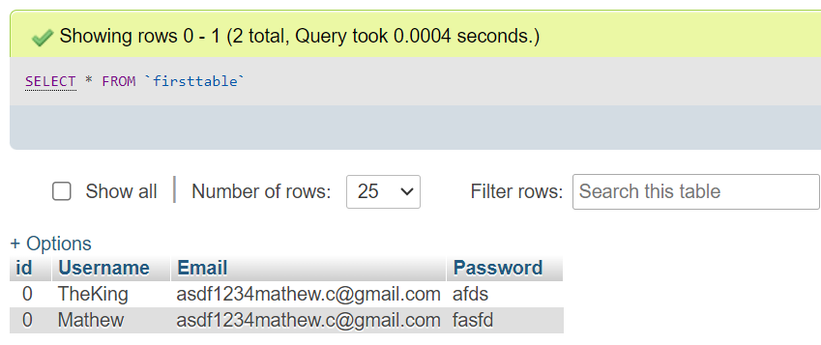

# Conclusion

In conclusion, my project is an e-commerce website focused on providing a seamless and user-friendly shopping experience for fitness enthusiasts. The website offers a wide range of gym equipment, electronics, clothing, and other relevant products to cater to the diverse needs of our customers.

Throughout the development process, I have prioritized creating an intuitive interface with easy navigation and search functionalities. The product listings provide comprehensive details, including images, descriptions, and pricing, empowering users to make well-informed purchasing decisions.

Additionally, the website incorporates personalized user accounts, enabling users to manage their preferences. This personalized experience contributes to building long-term customer relationships and facilitating future purchases.

Overall, my project strives to deliver a comprehensive and enjoyable shopping experience, combining a diverse product range, user-friendly interface, secure transactions, and personalized features. By creating an online platform that meets the needs of fitness enthusiasts, I aim to make their shopping journey convenient, efficient, and satisfying.